REMOVE LM
TUP TAGUIG
Mechanical And Allied Department

CHANGE THE TAB
- Our Expertise
Change to: System Overview
- 8 Stage Circuit
Change to: System Components & How the system works
- Safety Protocols
Change to: Outlet Area
- 7 Step SOP
Change to: Standard Operating Procedure
- Air Drops
Change to: Operating Procedure
- Video Demo REMAIN
- Lab Calculator - REMOVE
- Emergency Depressurized - REMAIN

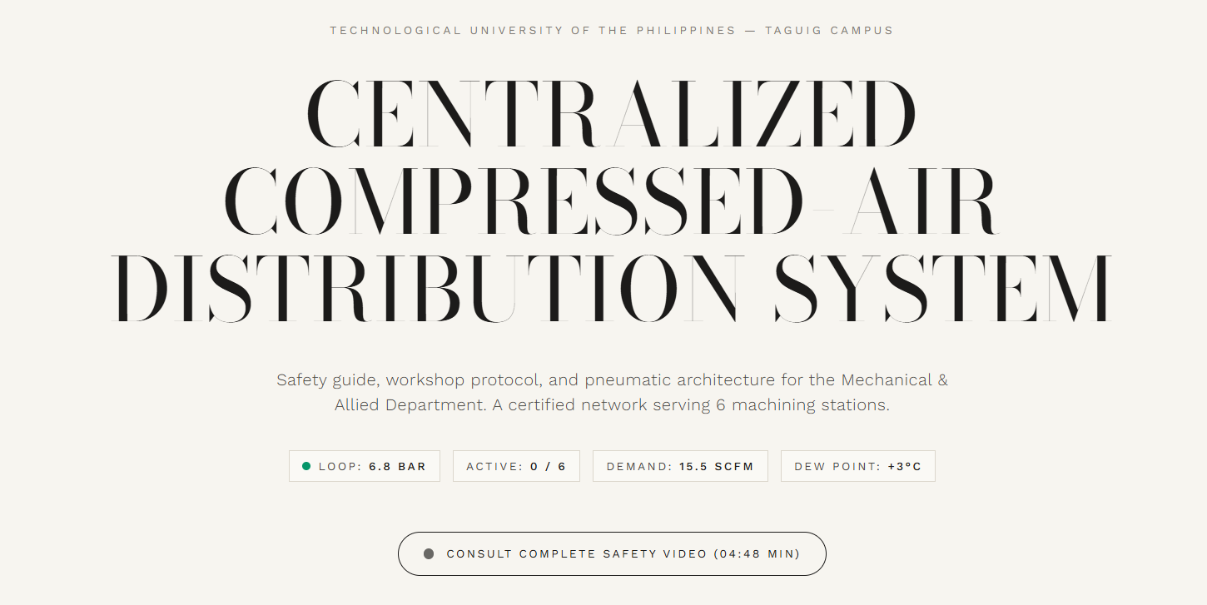

- TECHNOLOGICAL UNIVERSITY OF THE PHILIPPINES - TAGUIG CAMPUS
Change to: OPERATIONAL MANUAL

- CENTRALIZED COMPRESSED AIR DISTRIBUTION SYSTEM
Change the FONT

- Safety guide, workshop protocol, and pneumatic architecture for the Mechanical & Allied Department. A certified network serving 6 machining stations.
Change to: Explore the system overview, safety guidelines, operational procedures, and video demonstrations of our centralized compressed air system.
REMOVE
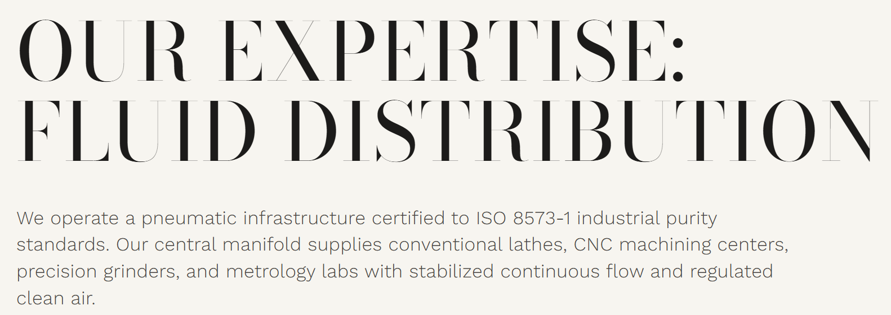

- OUR EXPERTISE: FLUID DISTRIBUTION
Change to: SYSTEM OVERVIEW
- We operate a pneumatic infrastructure certified to ISO 8573-1 industrial purity standards. Our central manifold supplies conventional lathes, CNC machining centers, precision grinders, and metrology labs with stabilized continuous flow and regulated clean air.
Change to: An overview of the centralized compressed air distribution system, highlighting its major components, functions, and operating principles. It explains how compressed air is generated, treated, stored, and distributed through the piping network to six machining stations for efficient metal chip removal and other improved workshop operations.

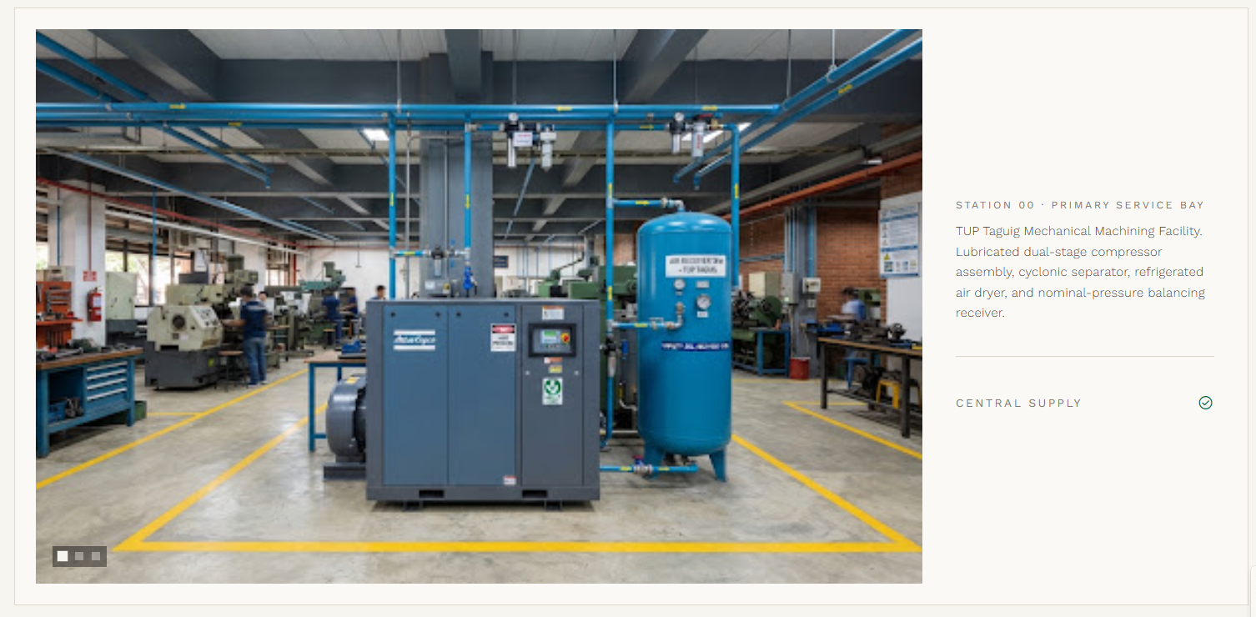

1st Picture
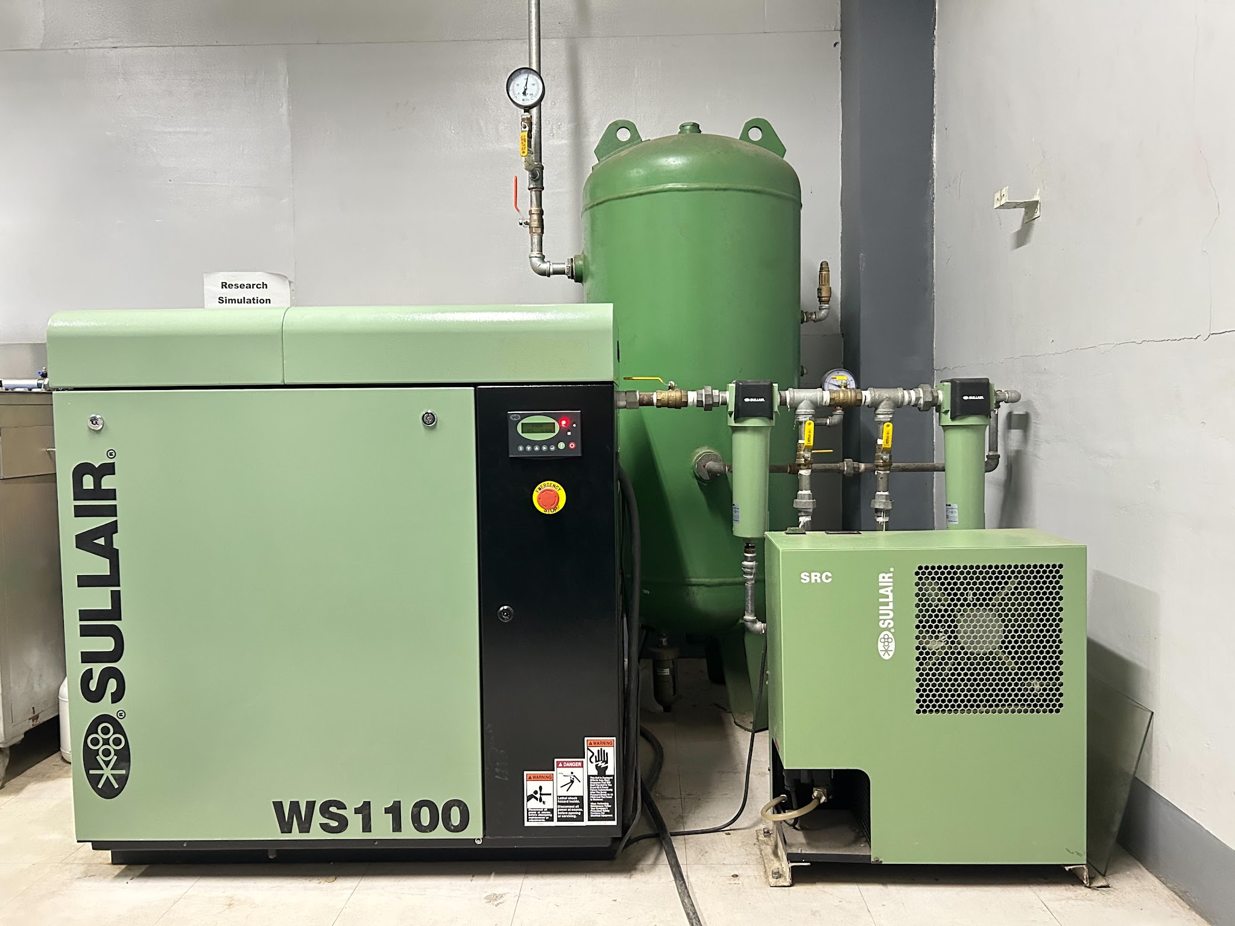
SYSTEM COMPONENTS

The system consists of an air compressor, air filter, refrigerant air dryer, and air receiver tank. Each component serves a specific function in generating, treating, and storing compressed air before it is distributed through the piping network to support efficient and reliable operation across the machining stations.

Central Supply

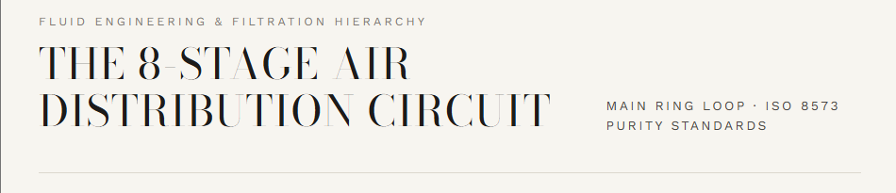

- Fluid Engineering & Filtration Hierarchy
Change to: SYSTEM COMPONENTS
- THE 8-STAGE AIR DISTRIBUTION CIRCUIT
Change to: HOW THE SYSTEM WORKS
- Main Ring Loop · ISO 8573 Purity Standards
REMOVE

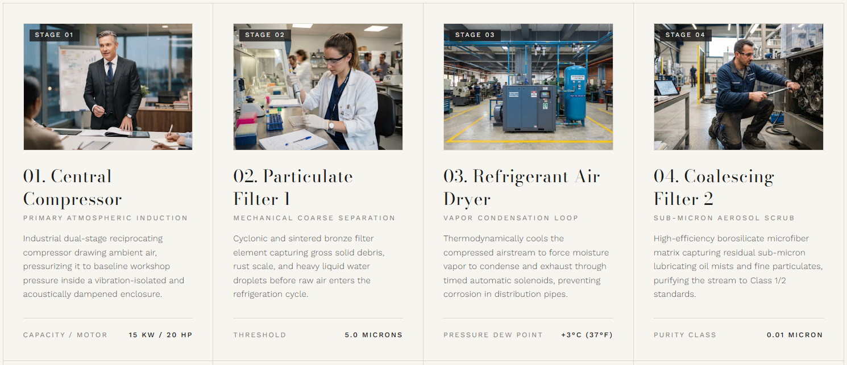

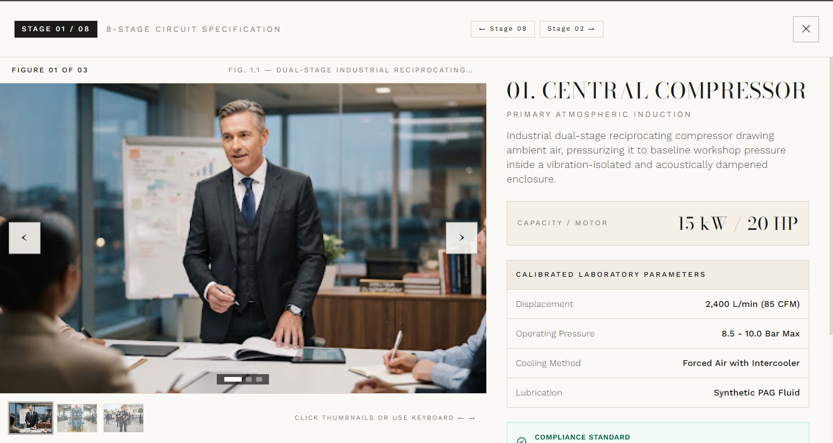

STAGE 1 (FIGURE 1)
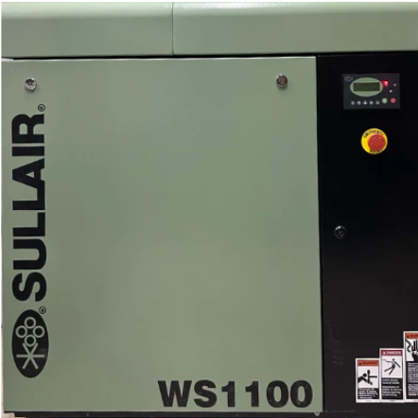
01. SULLAIR SCREW AIR COMPRESSOR
The air compressor draws in air from the surroundings and compresses it to provide the air supply needed by the system. It serves as the main source of compressed air.

CAPACITY/MOTOR: 125 PSIG/ 8.6 BAR

DETAILS
MODEL NO.: WS1109 AC
SERIAL NO.: 37218060003
EBOM NO.: 88291005-011

STAGE 1 (FIGURE 2)
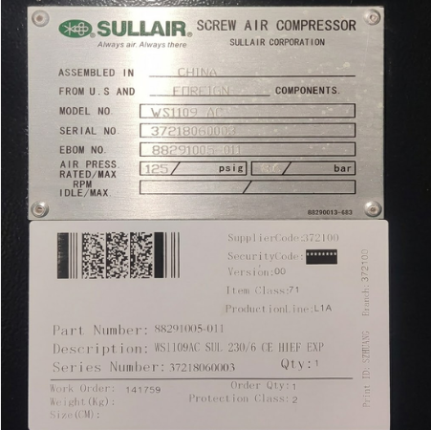

STAGE 2 (FIGURE 1)
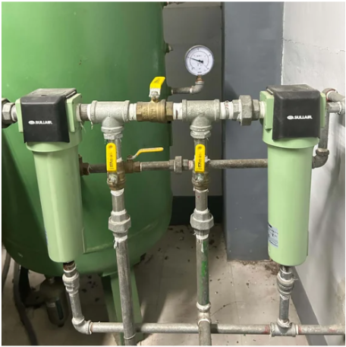
AIR FILTER
The air filter removes dirt, dust, and other solid particles from the compressed air to help protect the downstream components.

STAGE 3 (FIGURE 1)
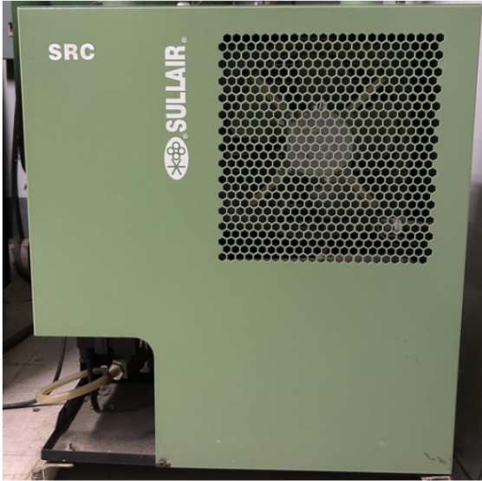
REFIGERANT DRYER
The refrigerant air dryer removes moisture from the compressed air by cooling it and collecting the water that forms. This helps prevent moisture buildup inside the pipes and protects the system components.

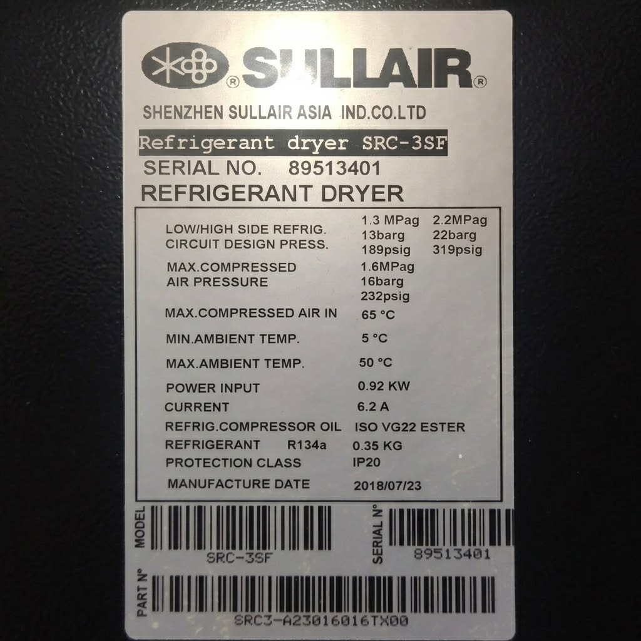
STAGE 3 (FIGURE 2)
DETAILS:
Low/High Side Refrig. Circuit Design Press.: 1.3 MPag / 2.2 MPag (13 barg / 22 barg, 189 psig / 319 psig)
Max. Compressed Air Pressure: 1.6 MPag (16 barg, 232 psig)
Max. Compressed Air In: 65 °C
Min. Ambient Temp.: 5 °C
Max. Ambient Temp.: 50 °C
Power Input: 0.92 kW
Current: 6.2 A
Refrig. Compressor Oil: ISO VG22 Ester
Refrigerant: R134a, 0.35 KG
Protection Class: IP20

STAGE 4 (FIGURE 1)
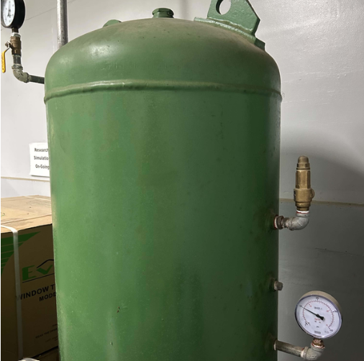
Air Receiver Tank
The air receiver tank stores compressed air and helps maintain a stable air supply when the system is in use. It also helps manage changes in air demand.
DETAILS
Serial No.: 19043 AR
Capacity: 300 Liters
Test Pressure: 15 BARS
Working Pressure: 10 BARS

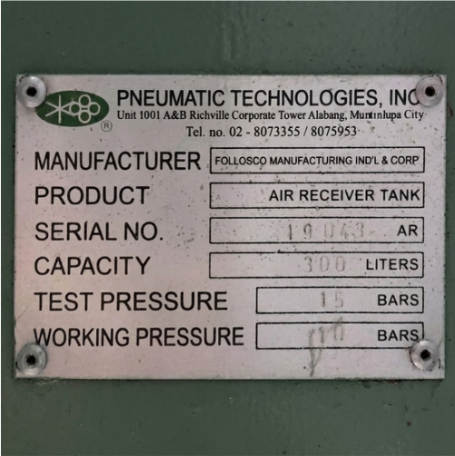
STAGE 4 (FIGURE 2)

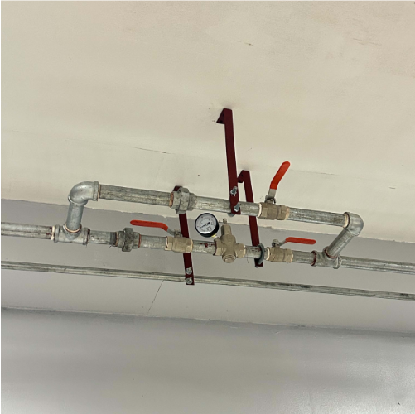
STAGE 5 (FIGURE 1)
Pressure Reducing Valve (PRV)
The pressure reducing valve (PRV) lowers and controls the air pressure before it enters the retractable hose reel and air blow gun. In our system, the PRV is set to 30 PSI to provide the needed air pressure for removing metal chips from machine surfaces.

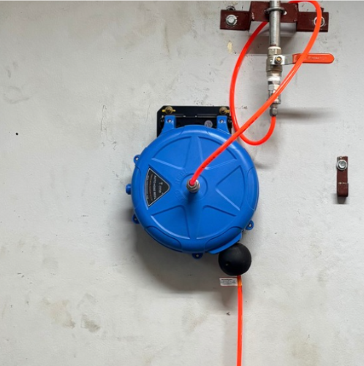
STAGE 6 (FIGURE 1)
Retractable Hose Reel
The retractable hose reel holds the air hose and allows users to pull it out when needed. After use, the hose can be pulled back into the reel, keeping the work area neat and organized.

STAGE 7 (FIGURE 2)
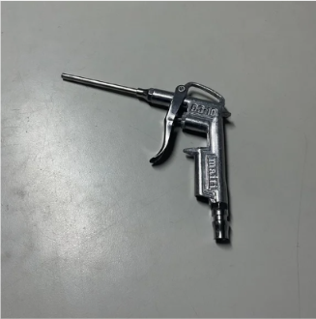
Air Blow Gun
The air blow gun directs compressed air toward machine surfaces to remove metal chips and debris after machining. It allows users to clean the machines more easily, while proper handling helps prevent chips from flying toward people.

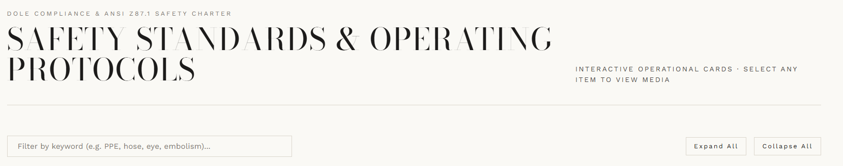
- DOLE Compliance & ANSI Z87.1 Safety Charter REMOVE
- Safety Standards & Operating Protocols REMAIN
- Interactive Operational Cards · Select any item to view media REMAIN

Required Personal Protective Equipment (PPE)
- Safety glasses
- Safety footwear
- Close-fitting work clothing
- No accessories
- Clean bun (for girls)
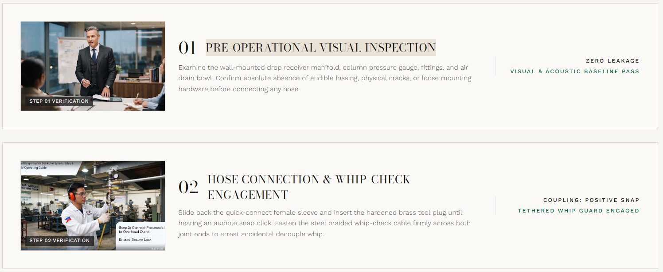
GANTO YUNG DESIGN SA DO’S & DONT’S
DO’s
- Wear the required PPE.
Always wear safety goggles and other required protective equipment to protect yourself from flying metal chips and debris during cleaning.

- Inspect the hose & fittings before use.
Inspect the pipes, hoses, and connections to make sure they are properly secured and free from visible damage or air leaks.

- Connect the tool securely.
Make sure the air blow gun is properly connected to the hose before use to prevent accidental disconnection and air leaks.

- Use the compressed air only for approved tasks.
Use the compressed air system only for its intended purpose, such as removing metal chips from machine surfaces, and follow the laboratory's safety procedures.

- Direct airflow away from people.
Always point the air blow gun toward the intended cleaning area and away from yourself and other people to prevent injuries from compressed air and flying debris.

- Follow the approved pressure setting
Check that the pressure reducing valve (PRV) is set to 30 PSI before using the air blow gun to maintain the required operating pressure.

- Keep hoses organized
Return the hose to the retractable hose reel after use to prevent tangling, tripping hazards, and unnecessary damage.

- Close the ball valve and release residual air after use.
Close the ball valve to stop the air supply, then release any remaining air before disconnecting the tool or performing maintenance.

- Report leaks, damage, or abnormal operations immediately.
Inform the laboratory instructor or responsible personnel if you notice air leaks, damaged components, unusual noises, or other problems. Stop using the system if it is unsafe until the issue has been checked.

DONT’S
- Don’t Use the System Without PPE
Operating without proper protective equipment may expose you to injuries from flying metal chips and debris.

- Do not point compressed air toward yourself or another person.
Never direct the air blow gun toward yourself or other people. The high-speed airflow can cause injuries, while flying metal chips and debris may hit the eyes or skin.

- Do not extend the limit of the retractable hose.
Avoid pulling the hose beyond its maximum extension. Doing so may damage the hose, affect the retractable mechanism, or cause the hose reel to malfunction.

- Do not step & leave the hose across walkways where it can create a tripping hazard.
Avoid leaving the hose across pathways or areas where people walk. It can create a tripping hazard and may also cause damage to the hose if someone steps on it.

- Do not exceed the designated operating pressure.
Never increase the pressure beyond the approved setting. Keep the pressure reducing valve (PRV) set to 30 PSI to maintain the required operating pressure and reduce potential safety risks.

- Do not use the system for other purposes than its intended application.
Use the centralized compressed air system only for its intended applications, such as removing metal chips from machine surfaces and operating compatible pneumatic tools.

- Do not operate or adjust the compressor without authorization.
Only operate the air compressor if you are authorized or have permission from the laboratory instructor or responsible personnel. Do not make adjustments without approval, as improper operation may damage the equipment or create unsafe conditions.

- Do not leave the hose & air tool unorganized.
Never leave the hose stretched out or the air blow gun in an improper location after use. Return the hose to the retractable reel and store the tool properly to prevent tangling, tripping hazards, and equipment damage.

- Don't disconnect components while the system is pressurized.
Never remove the tool while they contain compressed air. Shut off the air supply and release the trapped pressure according to the proper procedure before disconnecting them.

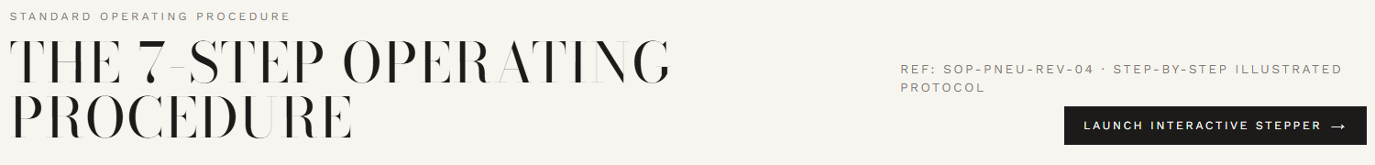
- STANDARD OPERATING PROCEDURE
Change to: STEP BY STEP
- THE 7 STEP OPERATING PROCEDURE
Change to: STANDARD OPERATING PROCEDURE
- Ref: SOP-PNEU-REV-04 · Step-by-Step Illustrated Protocol REMOVE

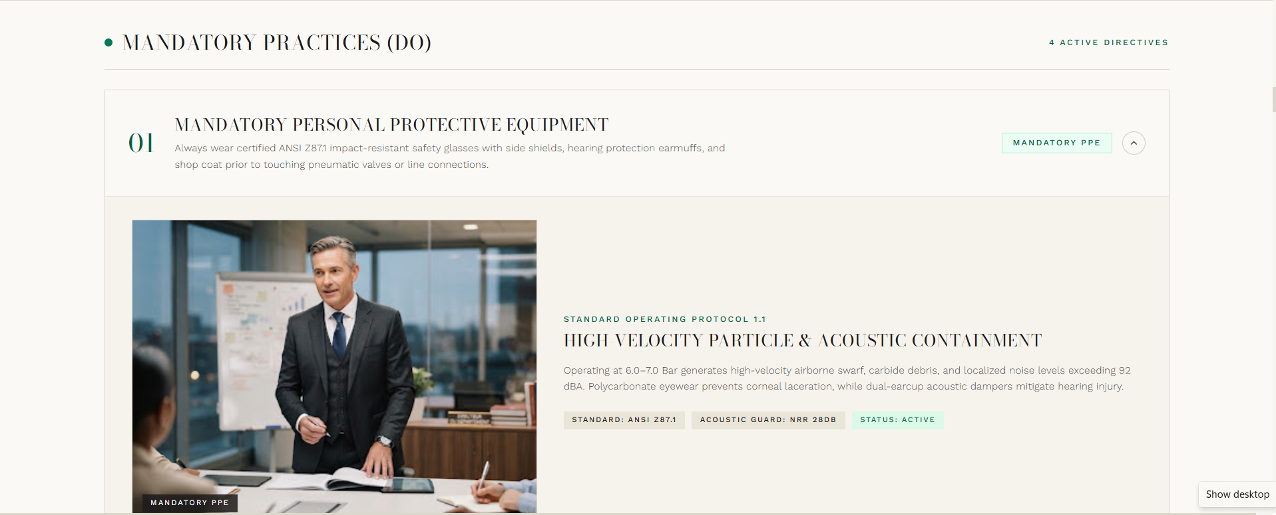
GANTO DESIGN DAPAT SA PROCEDURAL MANUAL
- MANDATORY PRACTICES (DO)
Change to: A. COMPRESSOR START UP

01 Starting the Air Compressor
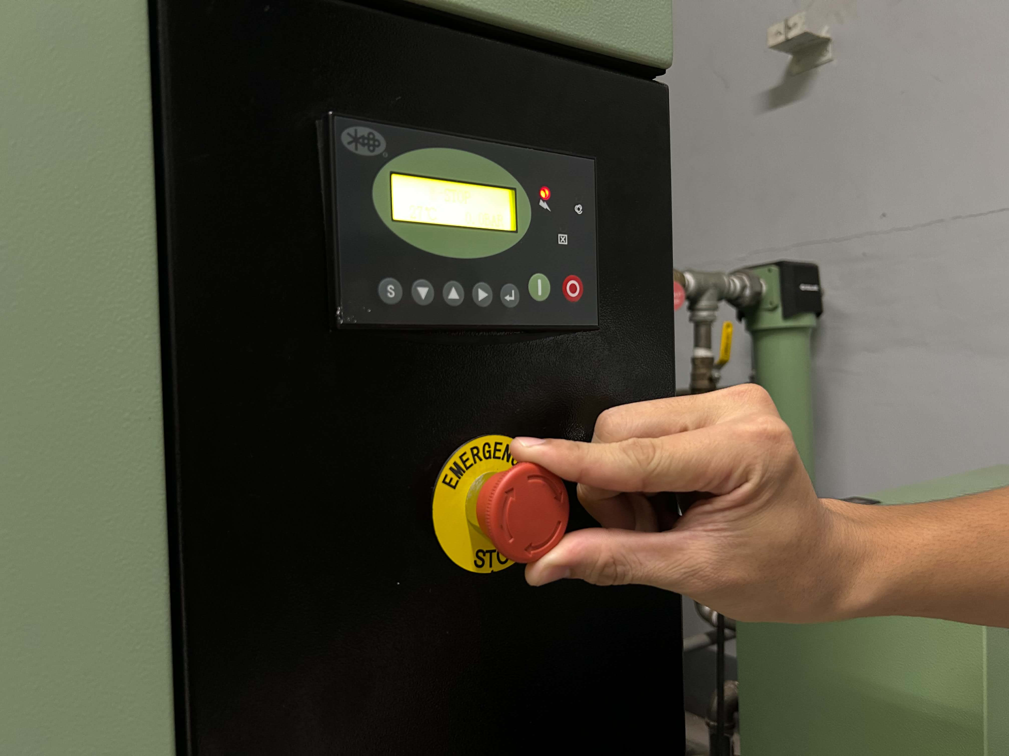
01 FIGURE 1
Make sure the air compressor is ready for operation. Release the emergency stop button by twisting it, then press the green start button to turn on the compressor.

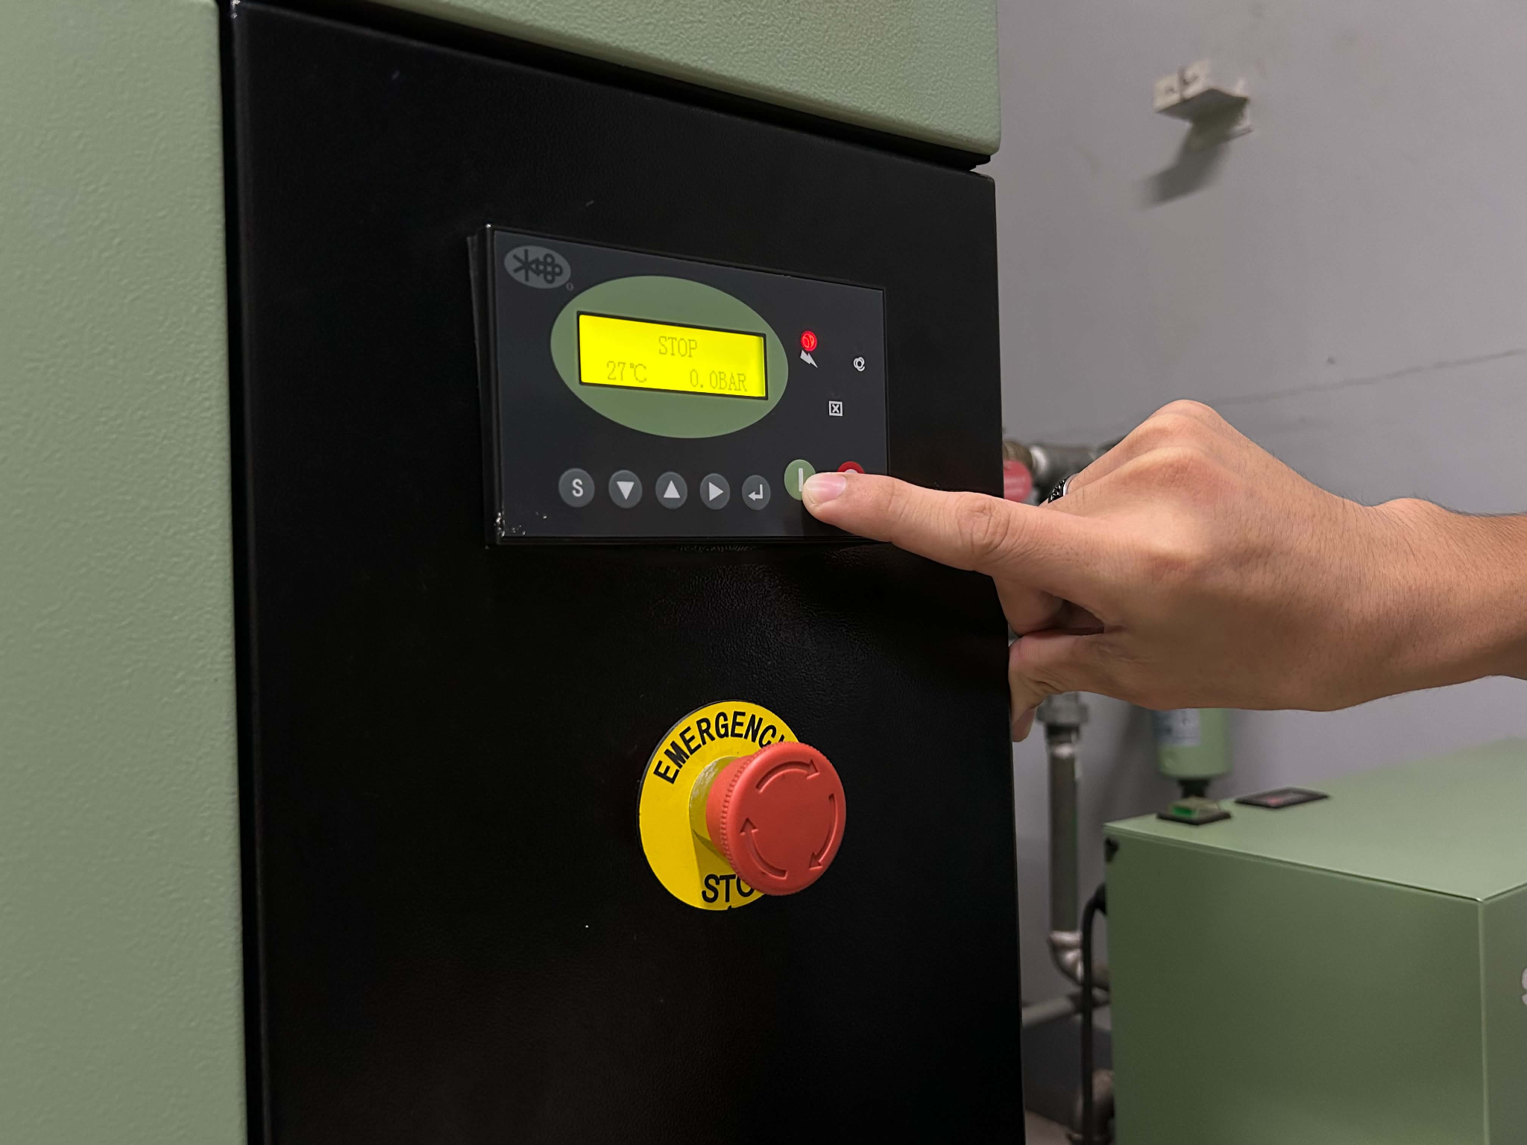
01 FIGURE 2

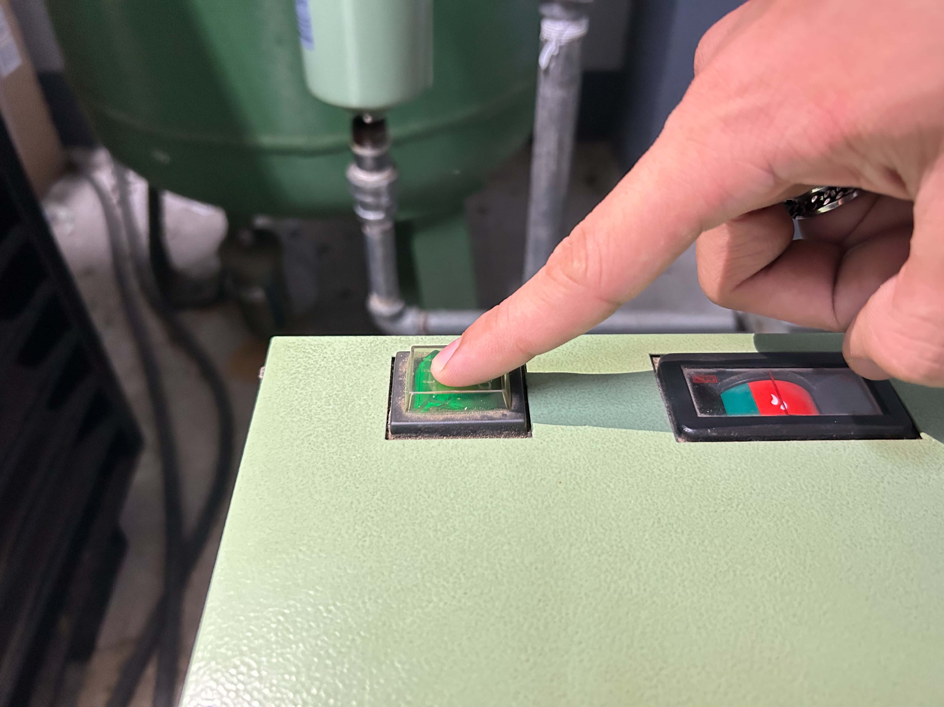
02 Starting the Refrigerant Air Dryer
02 FIGURE
Locate the refrigerant air dryer beside the compressor and press the green start button. The dryer removes moisture from the compressed air before it enters the distribution system.

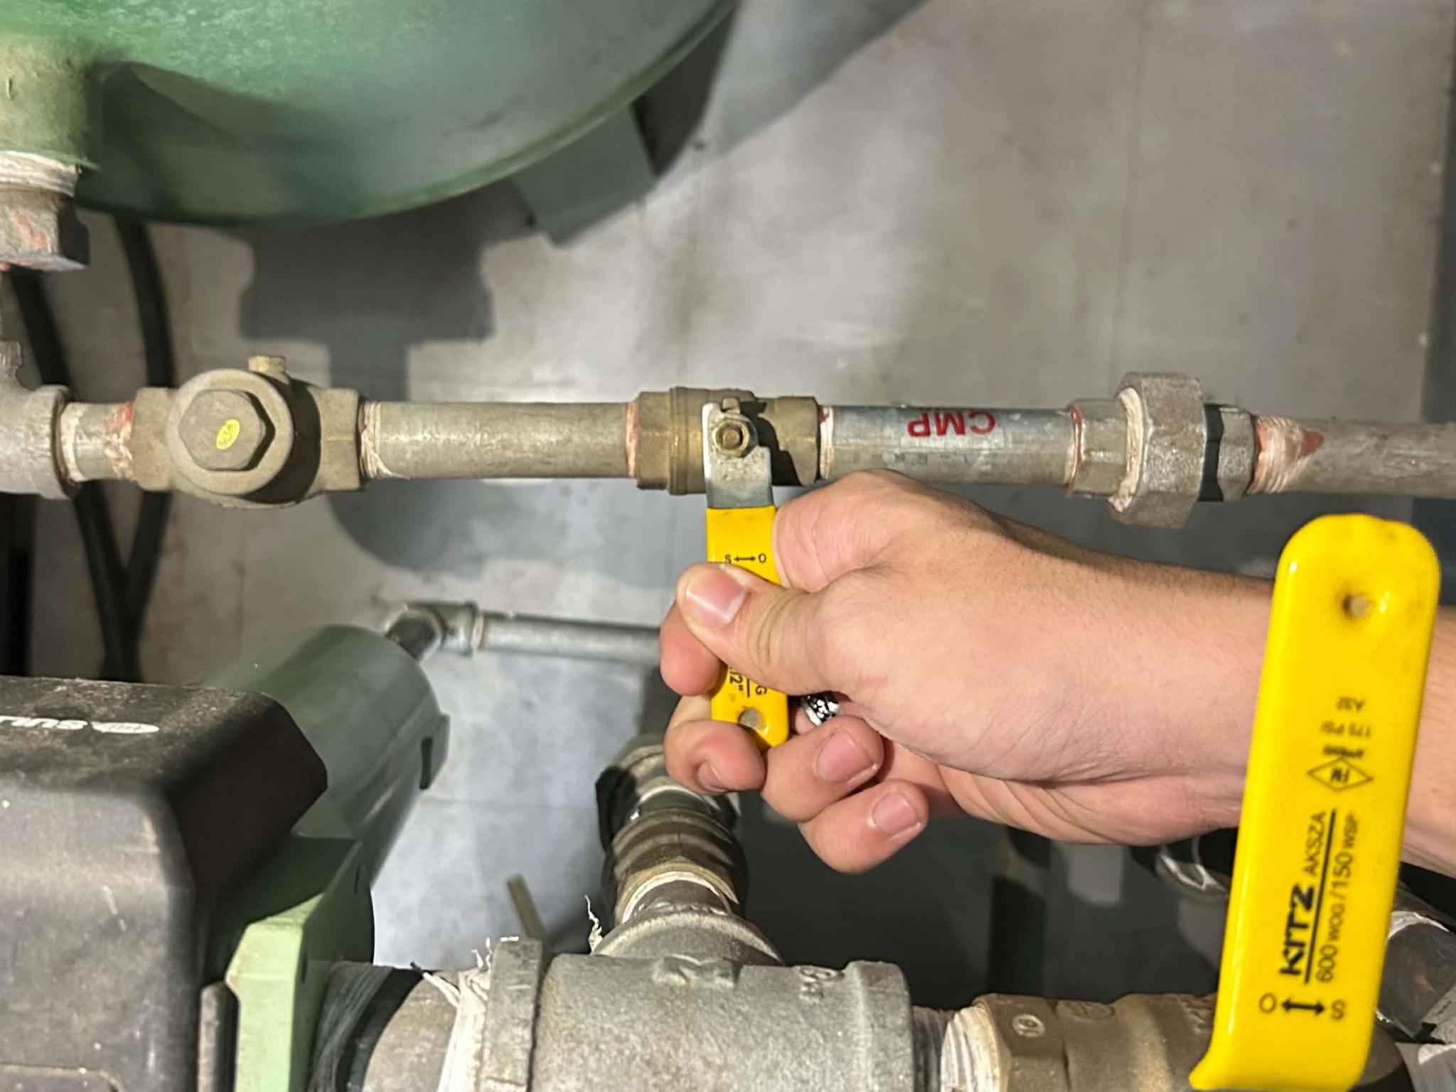
03 Opening the Air Receiver Tank Ball Valve
03 FIGURE 1
Open the ball valve beside the air receiver tank to allow compressed air to flow into the tank. Wait until the system reaches the required operating pressure before using it.

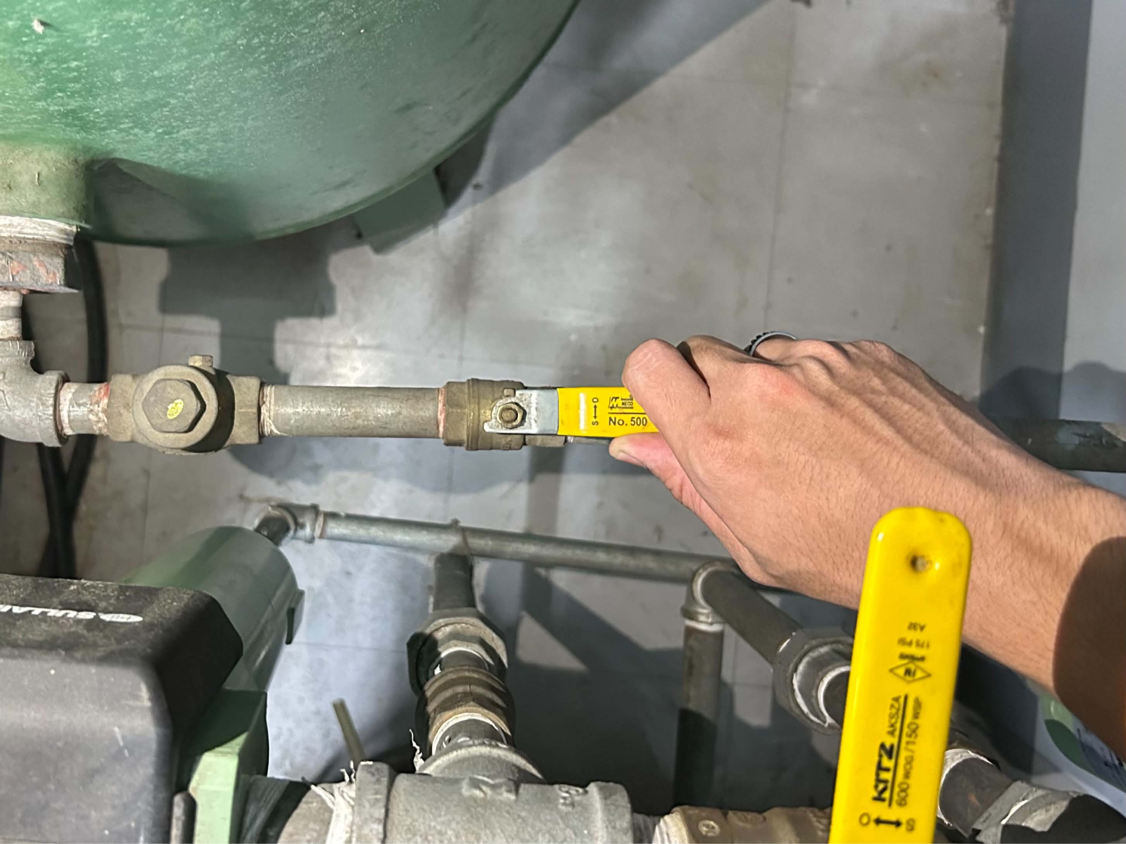
03 FIGURE 2

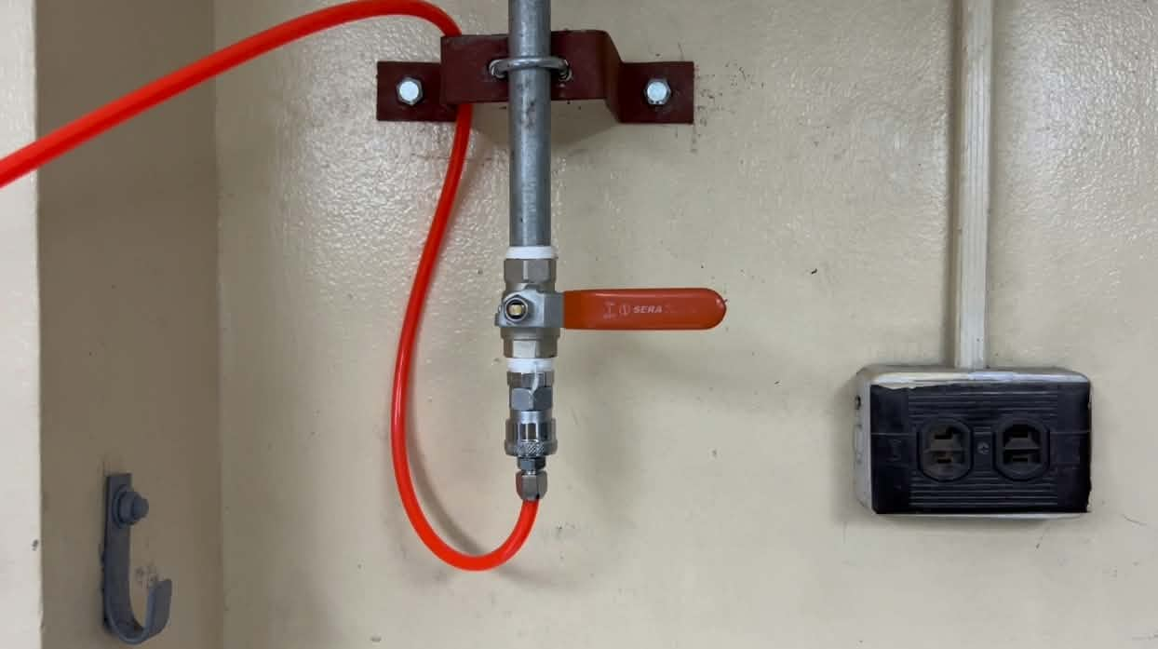
04. Checking the Upper Ball Valve
04 FIGURE 1
Before connecting the pneumatic tool, check that the upper ball valve is closed.

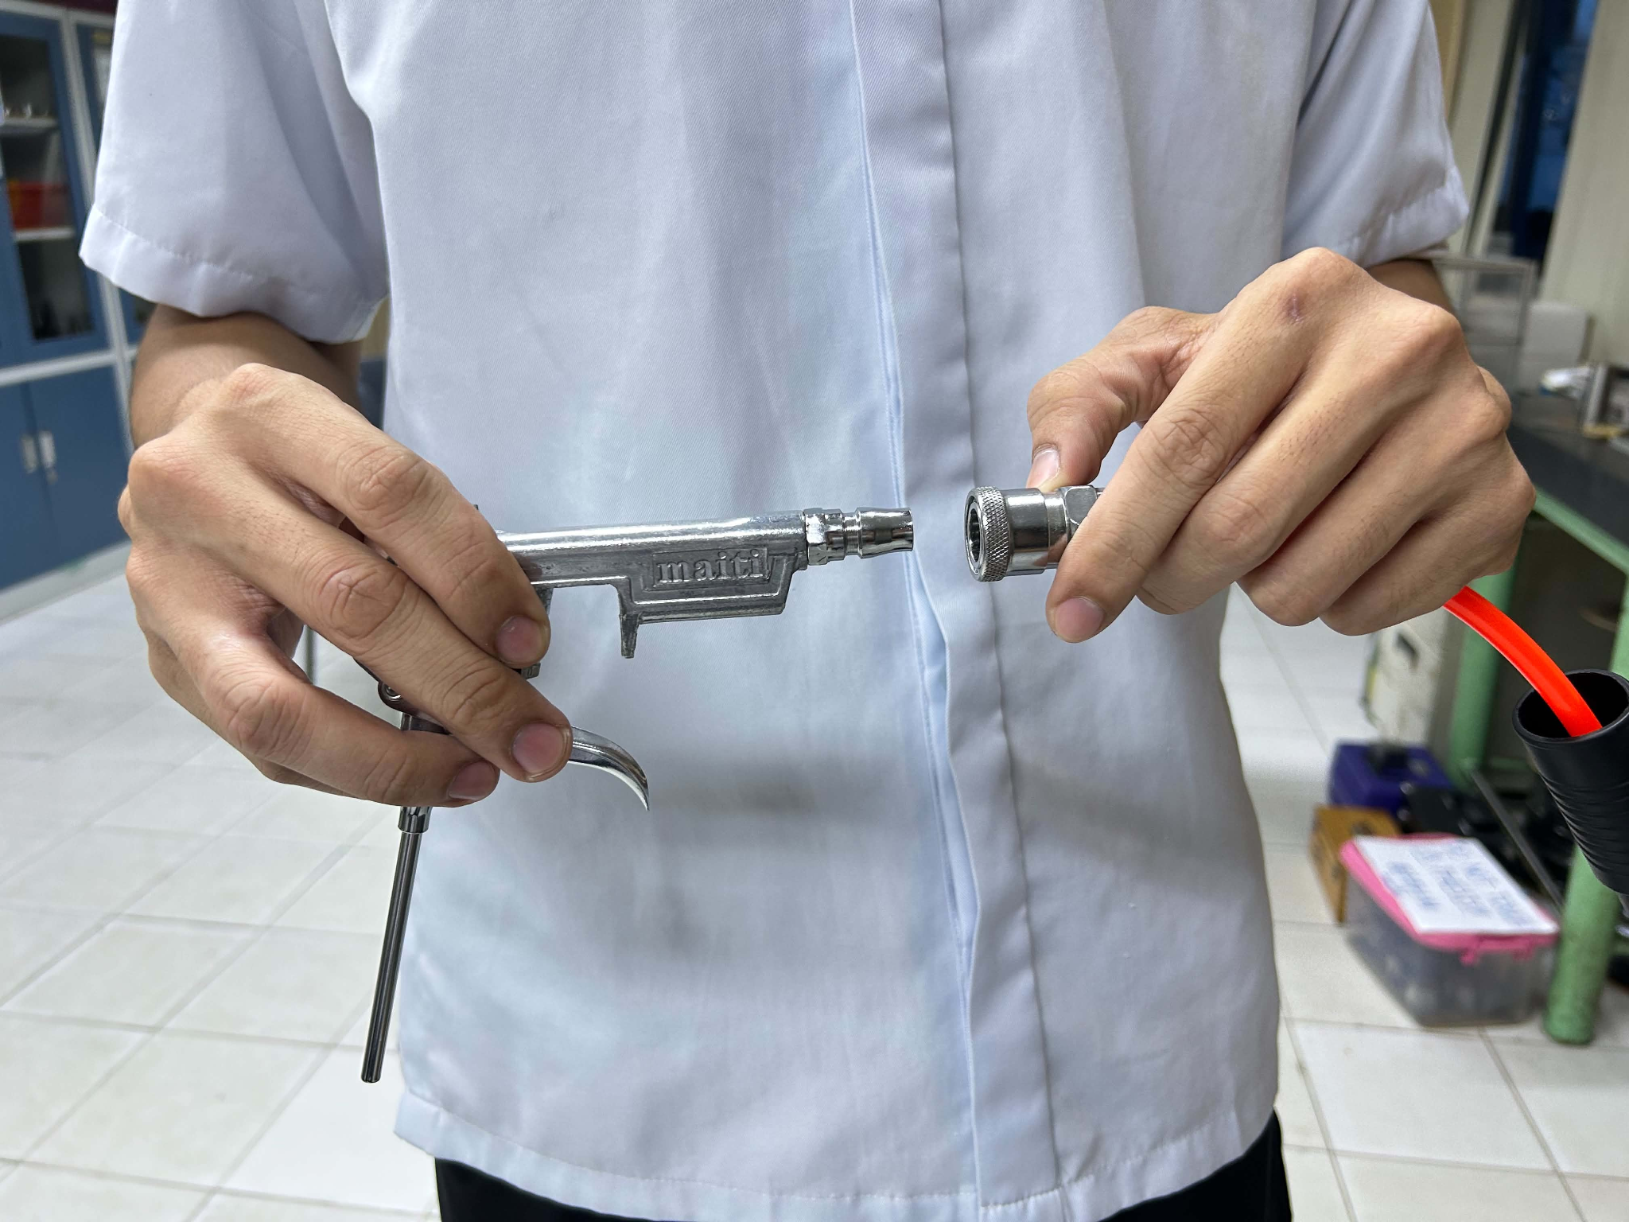
05 Connecting the tool to the Quick-Connect Fitting
05 FIGURE 01
Connect the air blow gun to the hose reel's quick-connect fitting. Pull back the quick-connect, insert the air blow gun fitting, and put back the black sleeve to secure the connection.

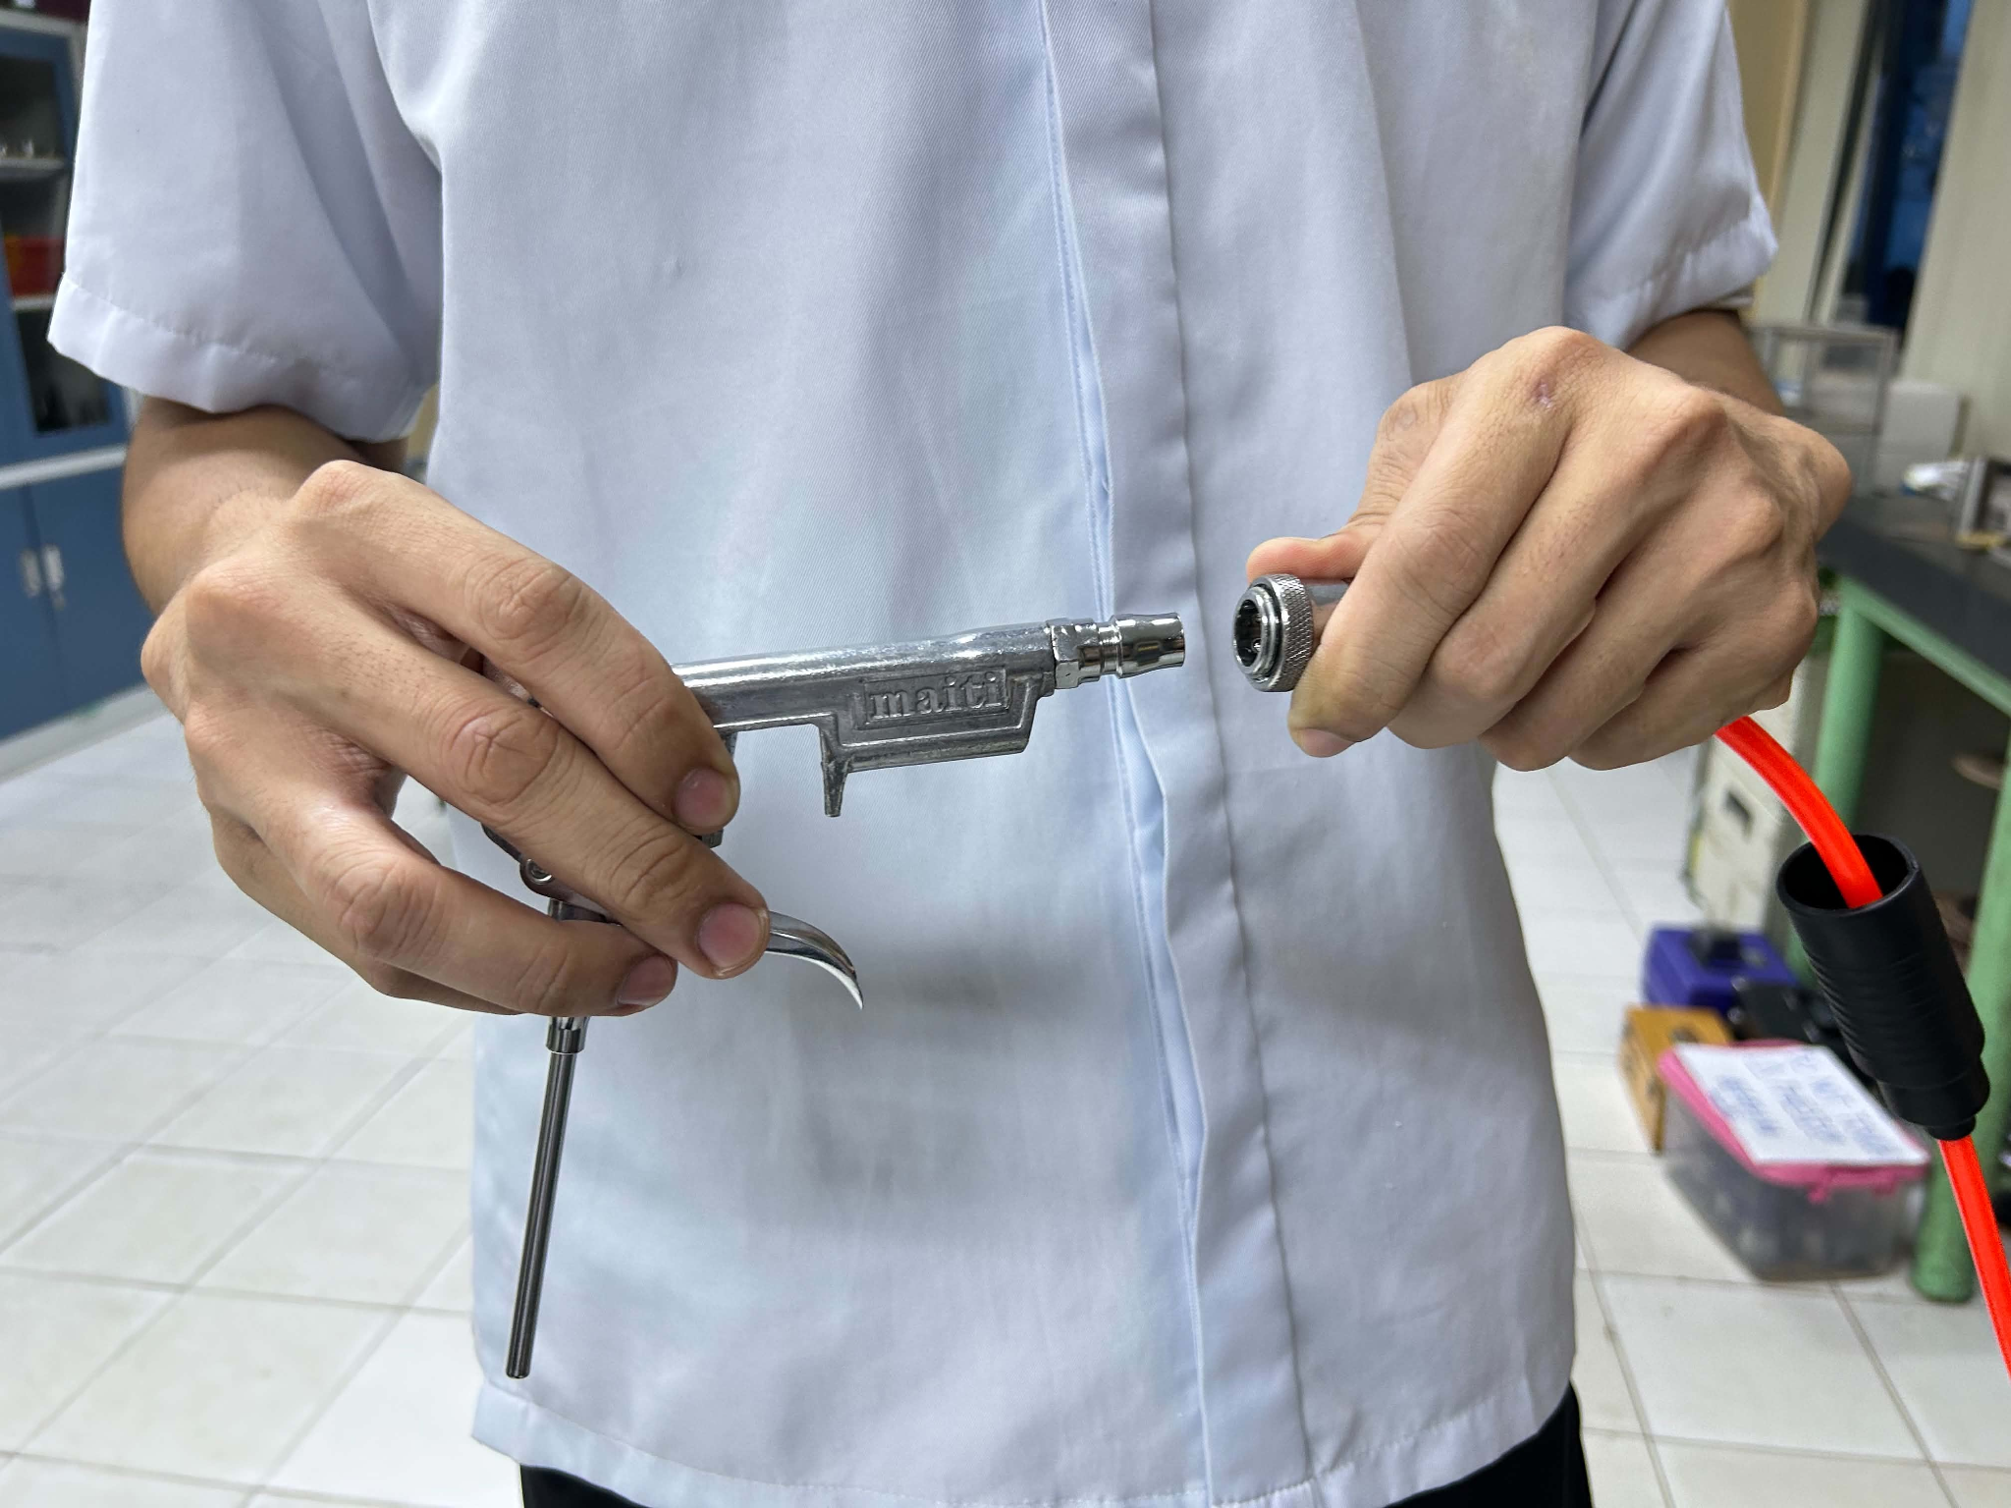
05 FIGURE 02

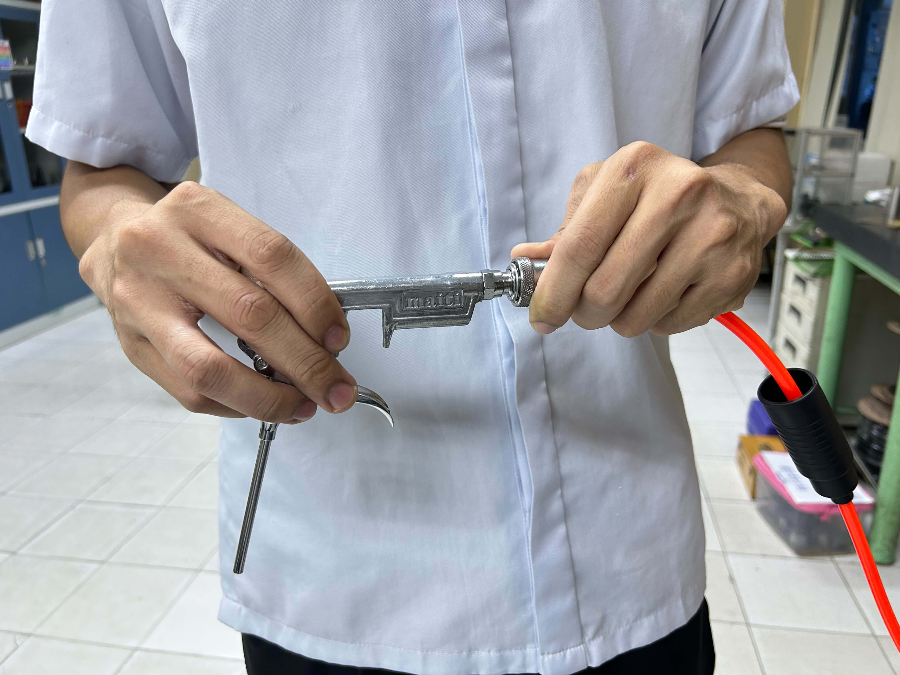
05 FIGURE 03
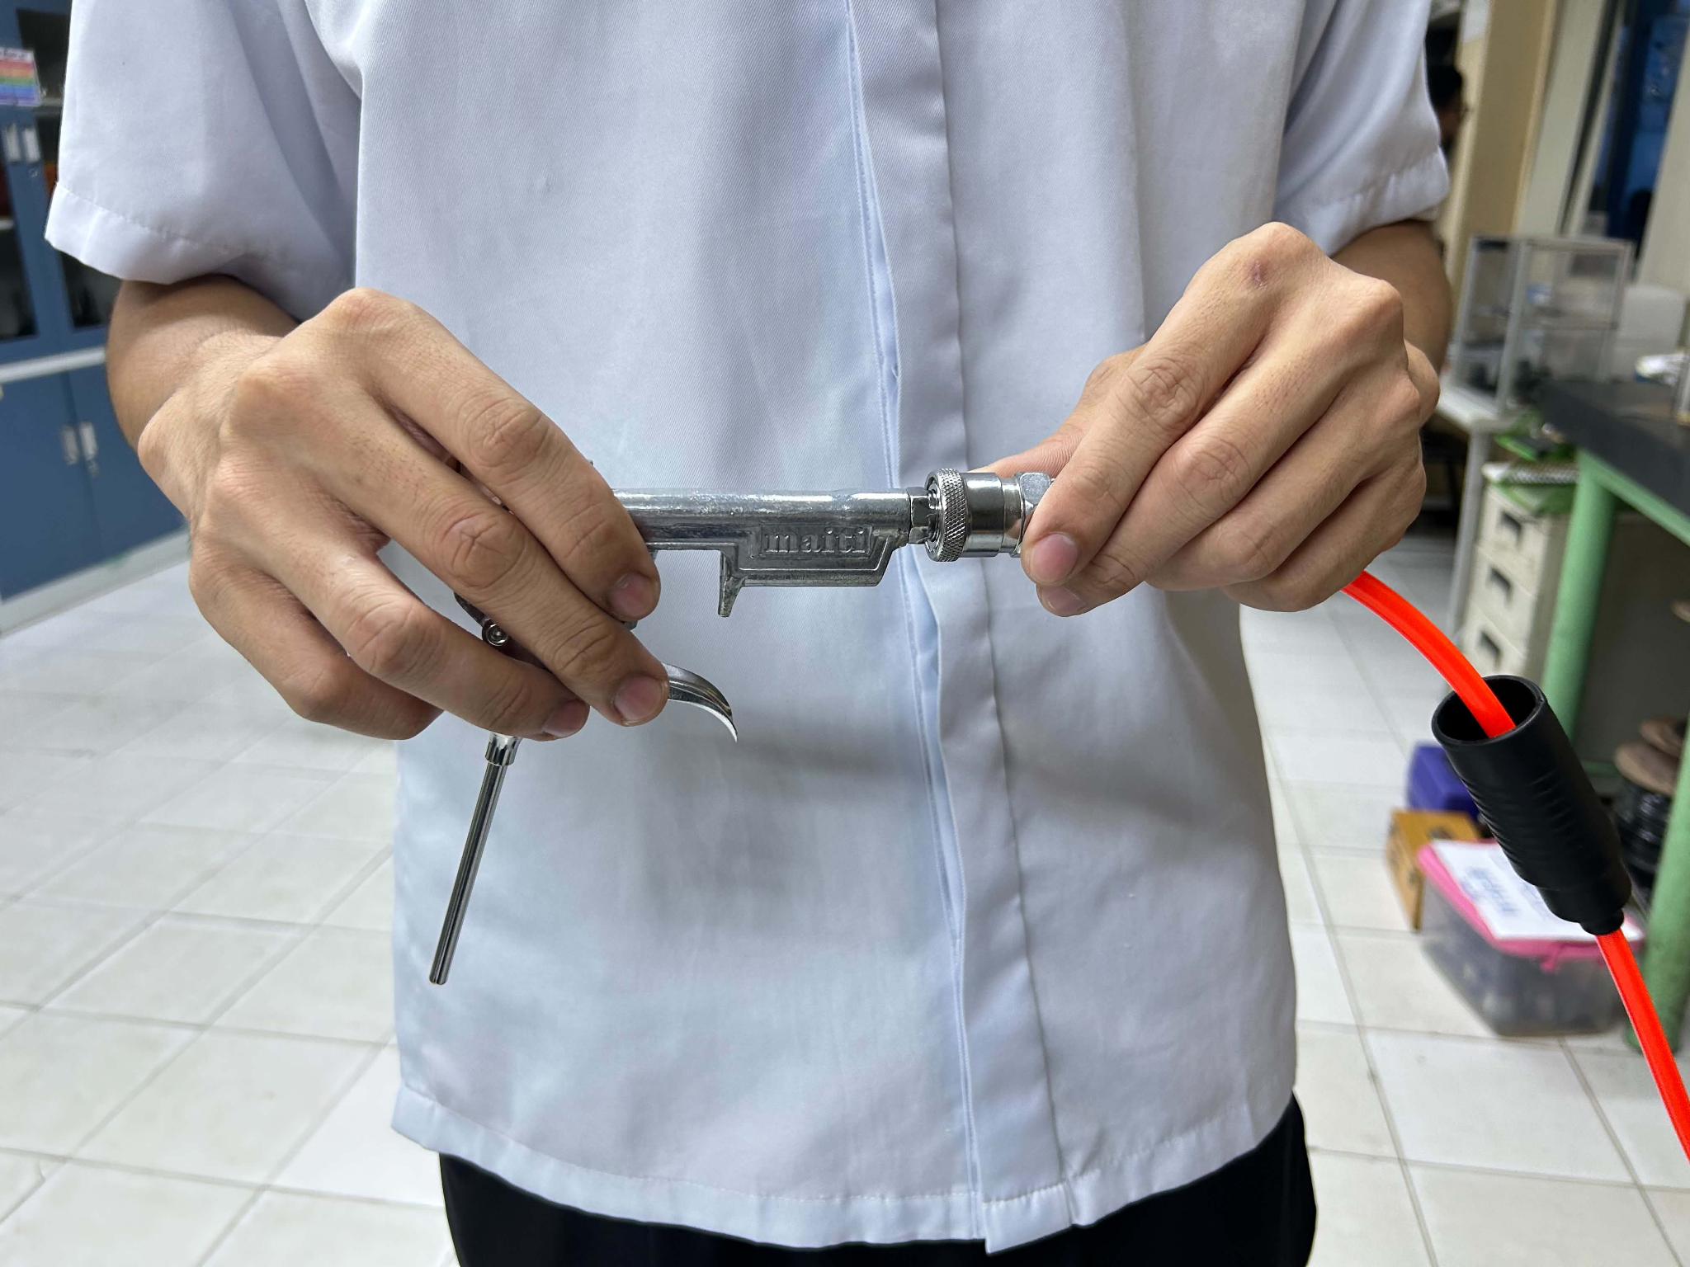
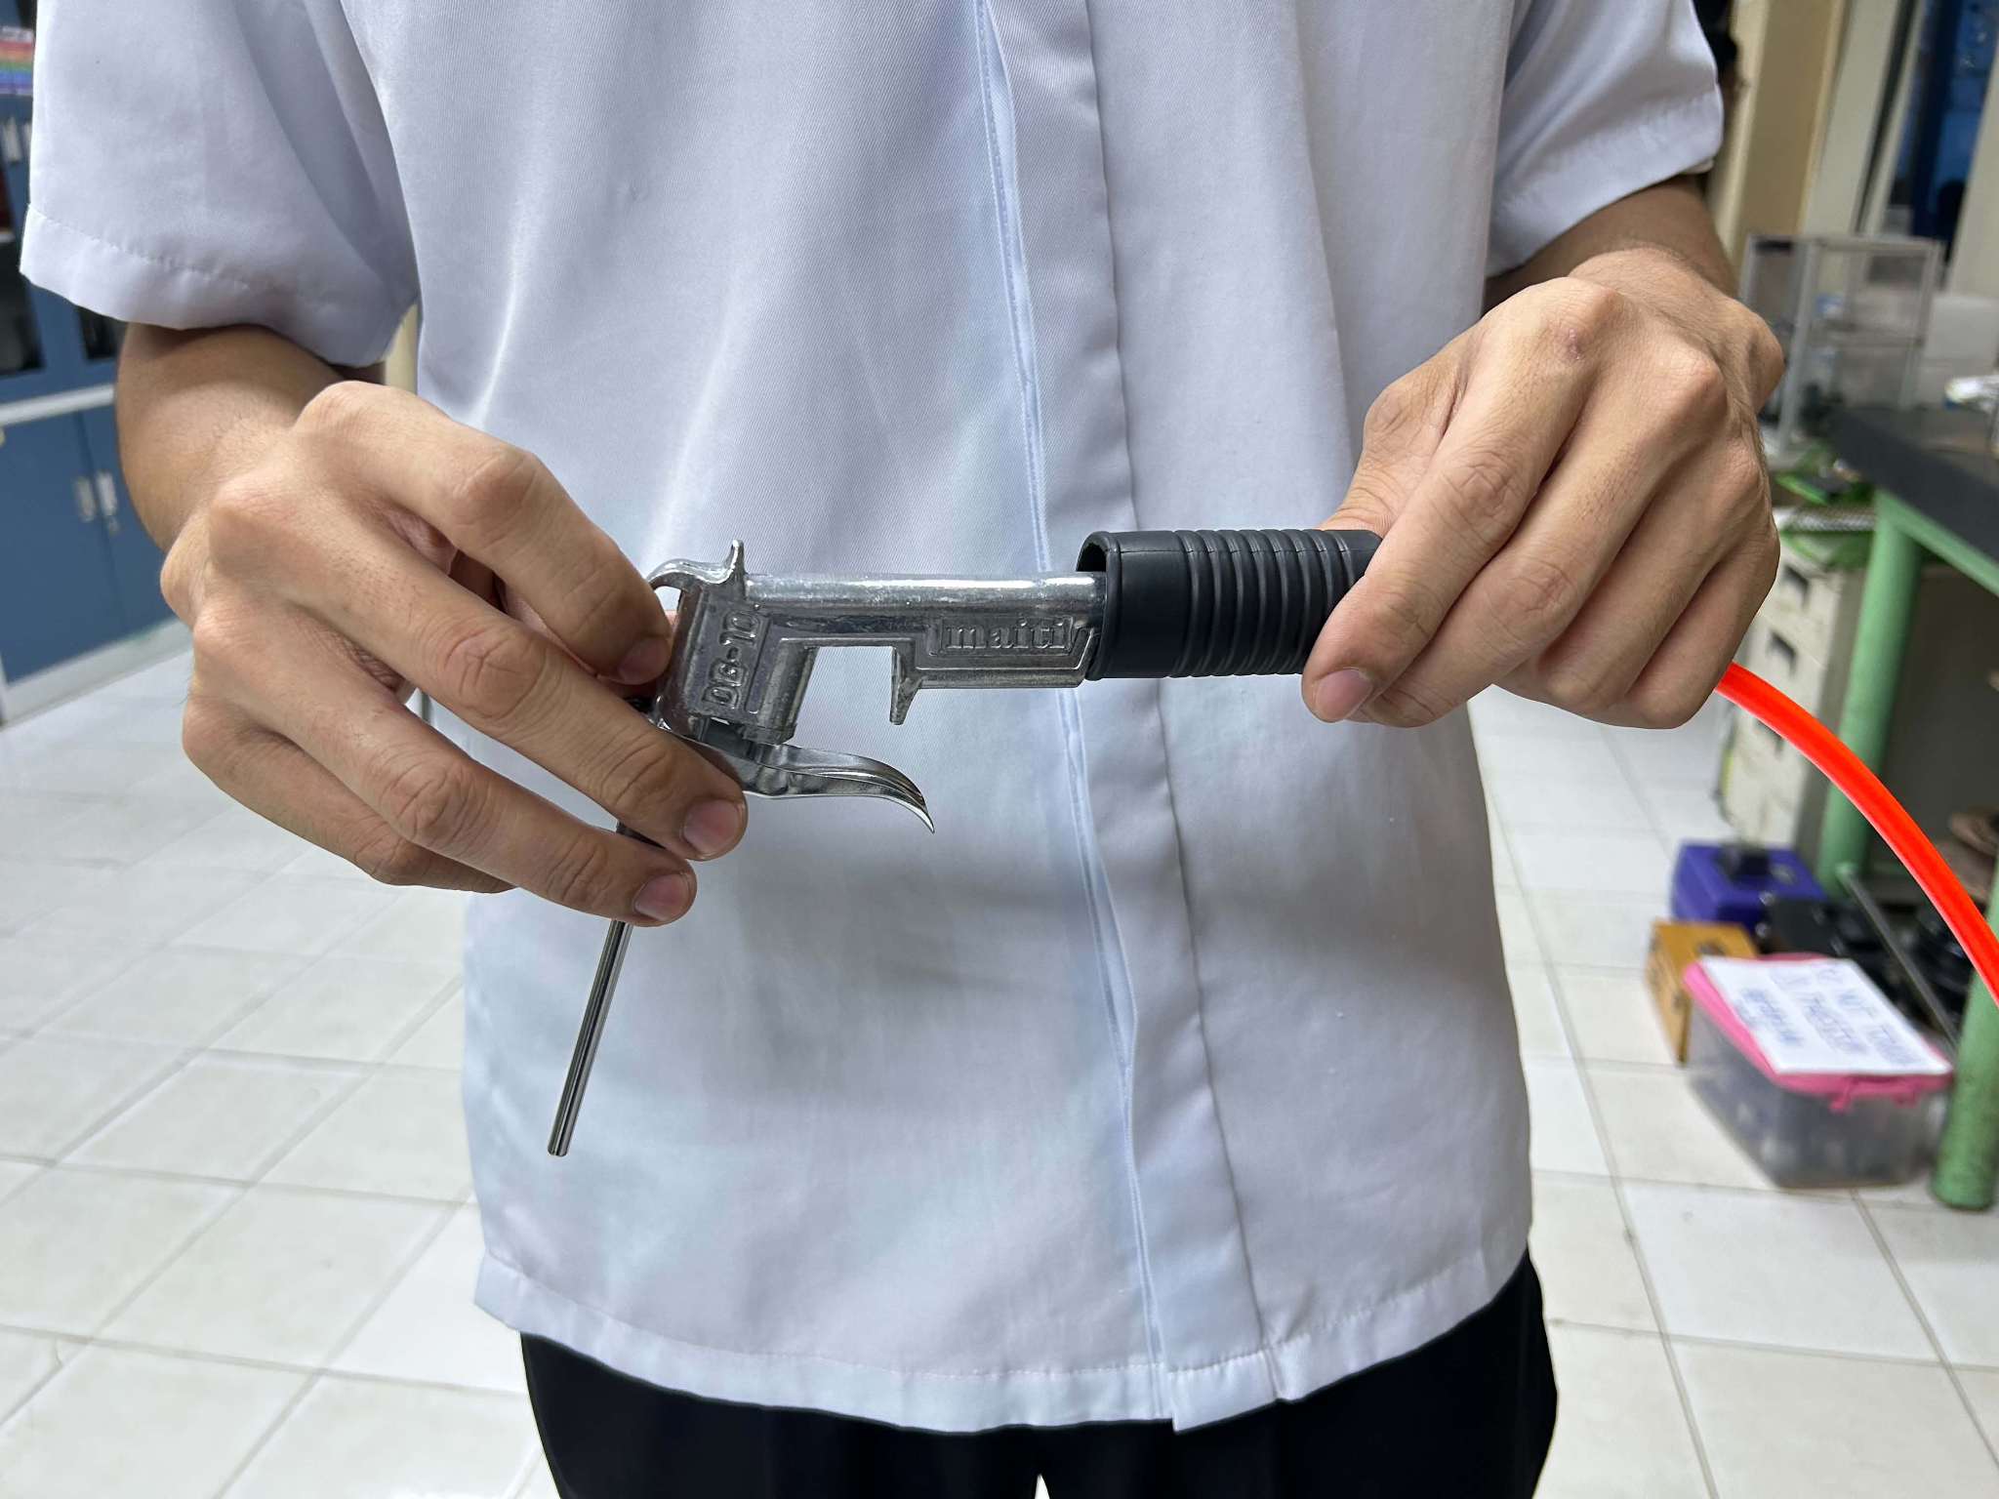

05 FIGURE 04

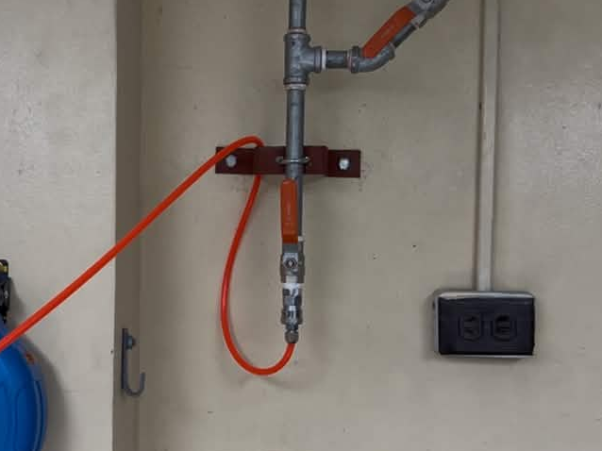
06 Open the Ball Valve
06 FIGURE 01

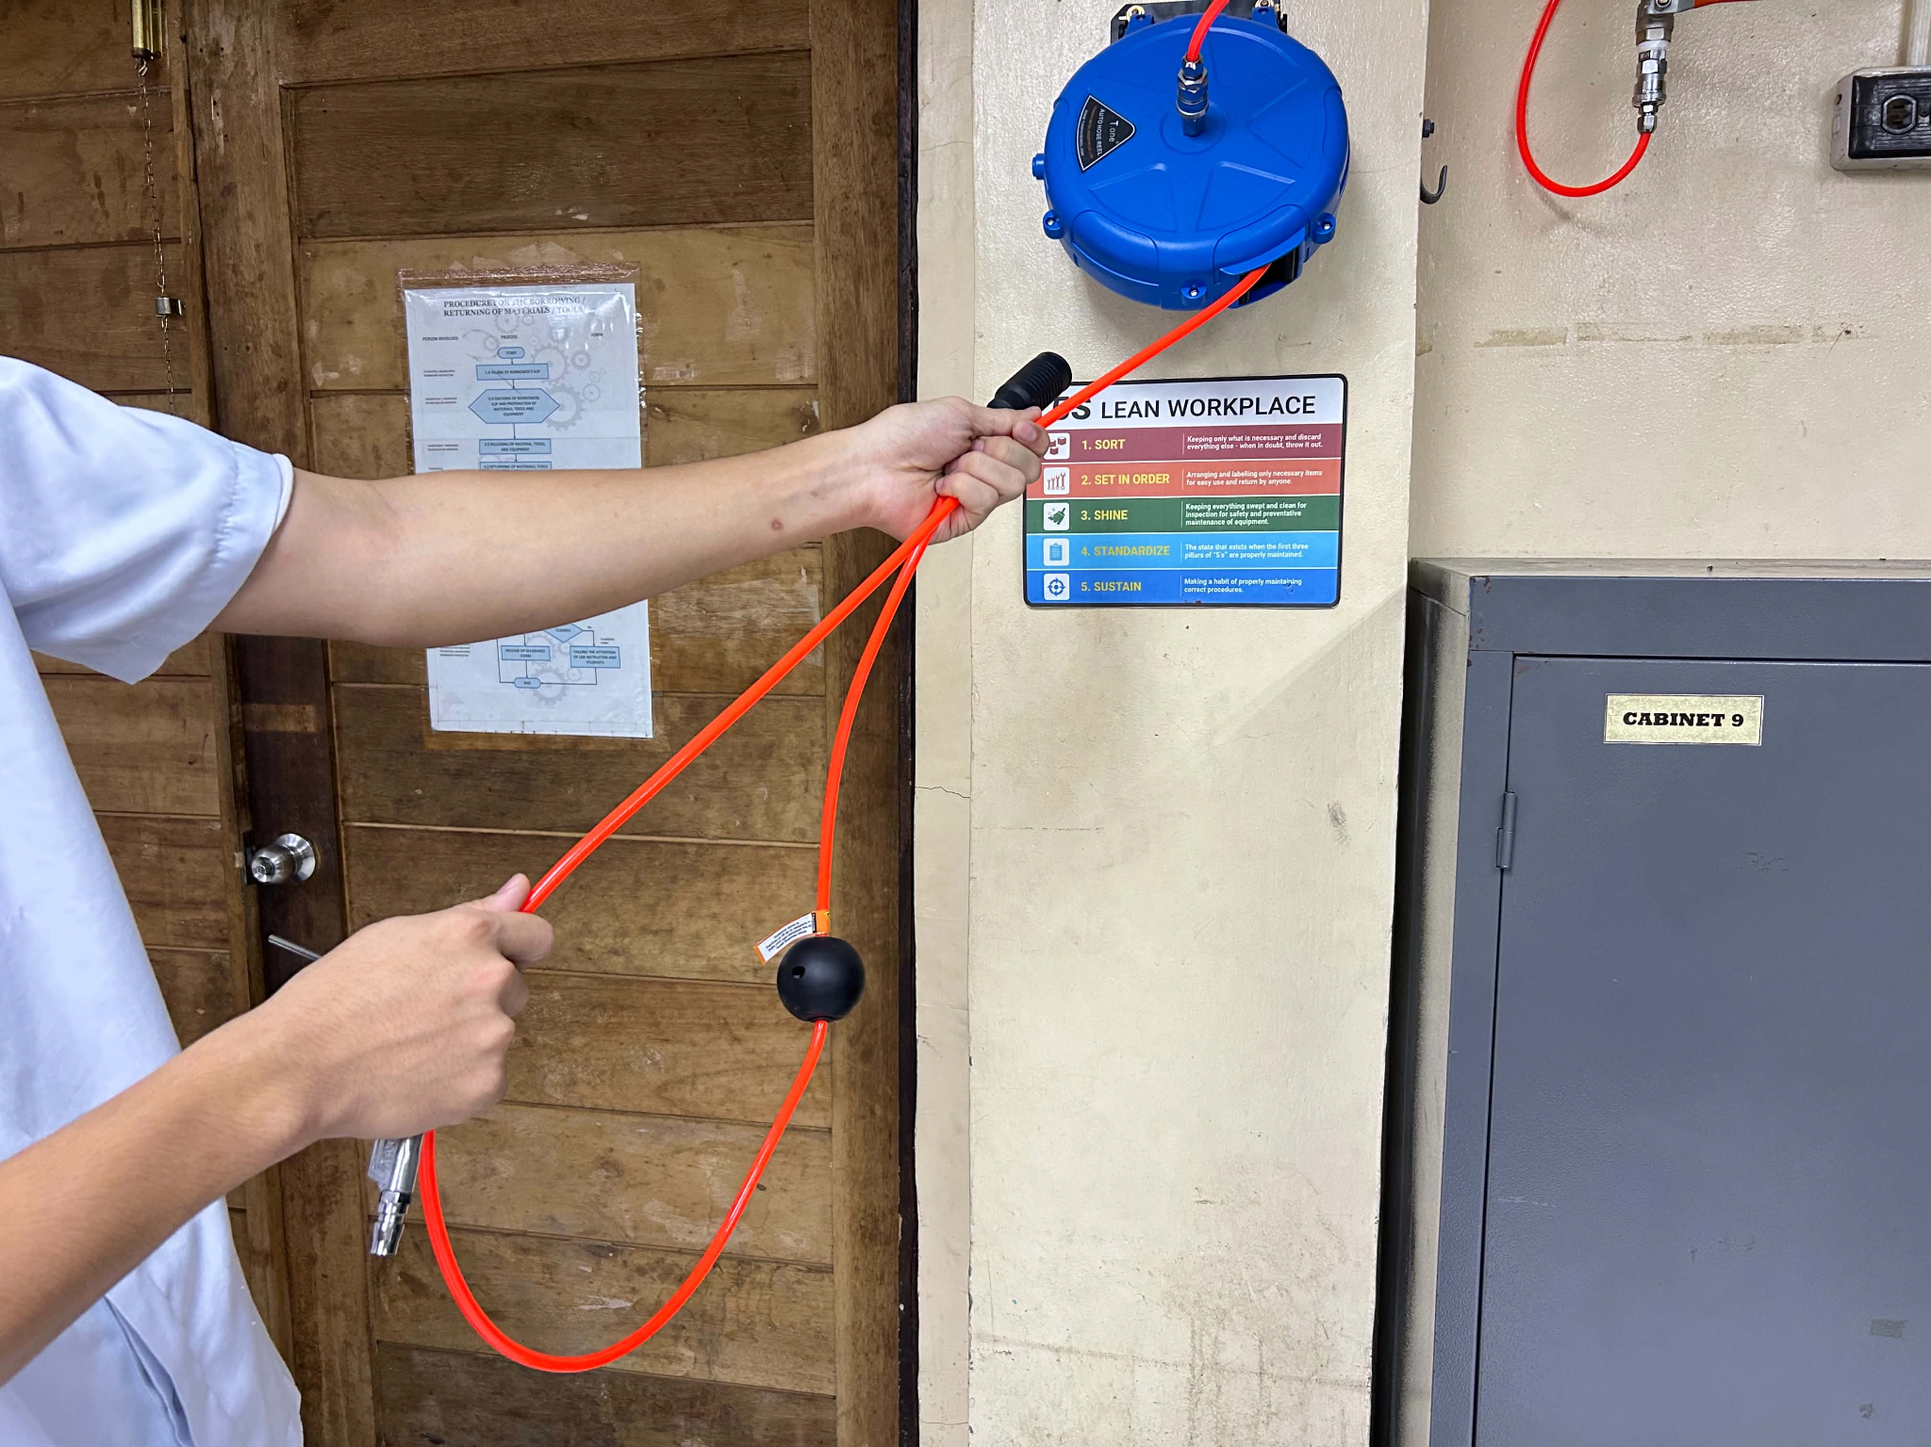
07 Extending the Retractable Hose Reel
07 FIGURE 01
Carefully pull the hose reel to extend the hose to the required working area. Avoid pulling the hose abruptly or allowing it to become tangled. Make sure the hose is positioned properly and does not block walkways.

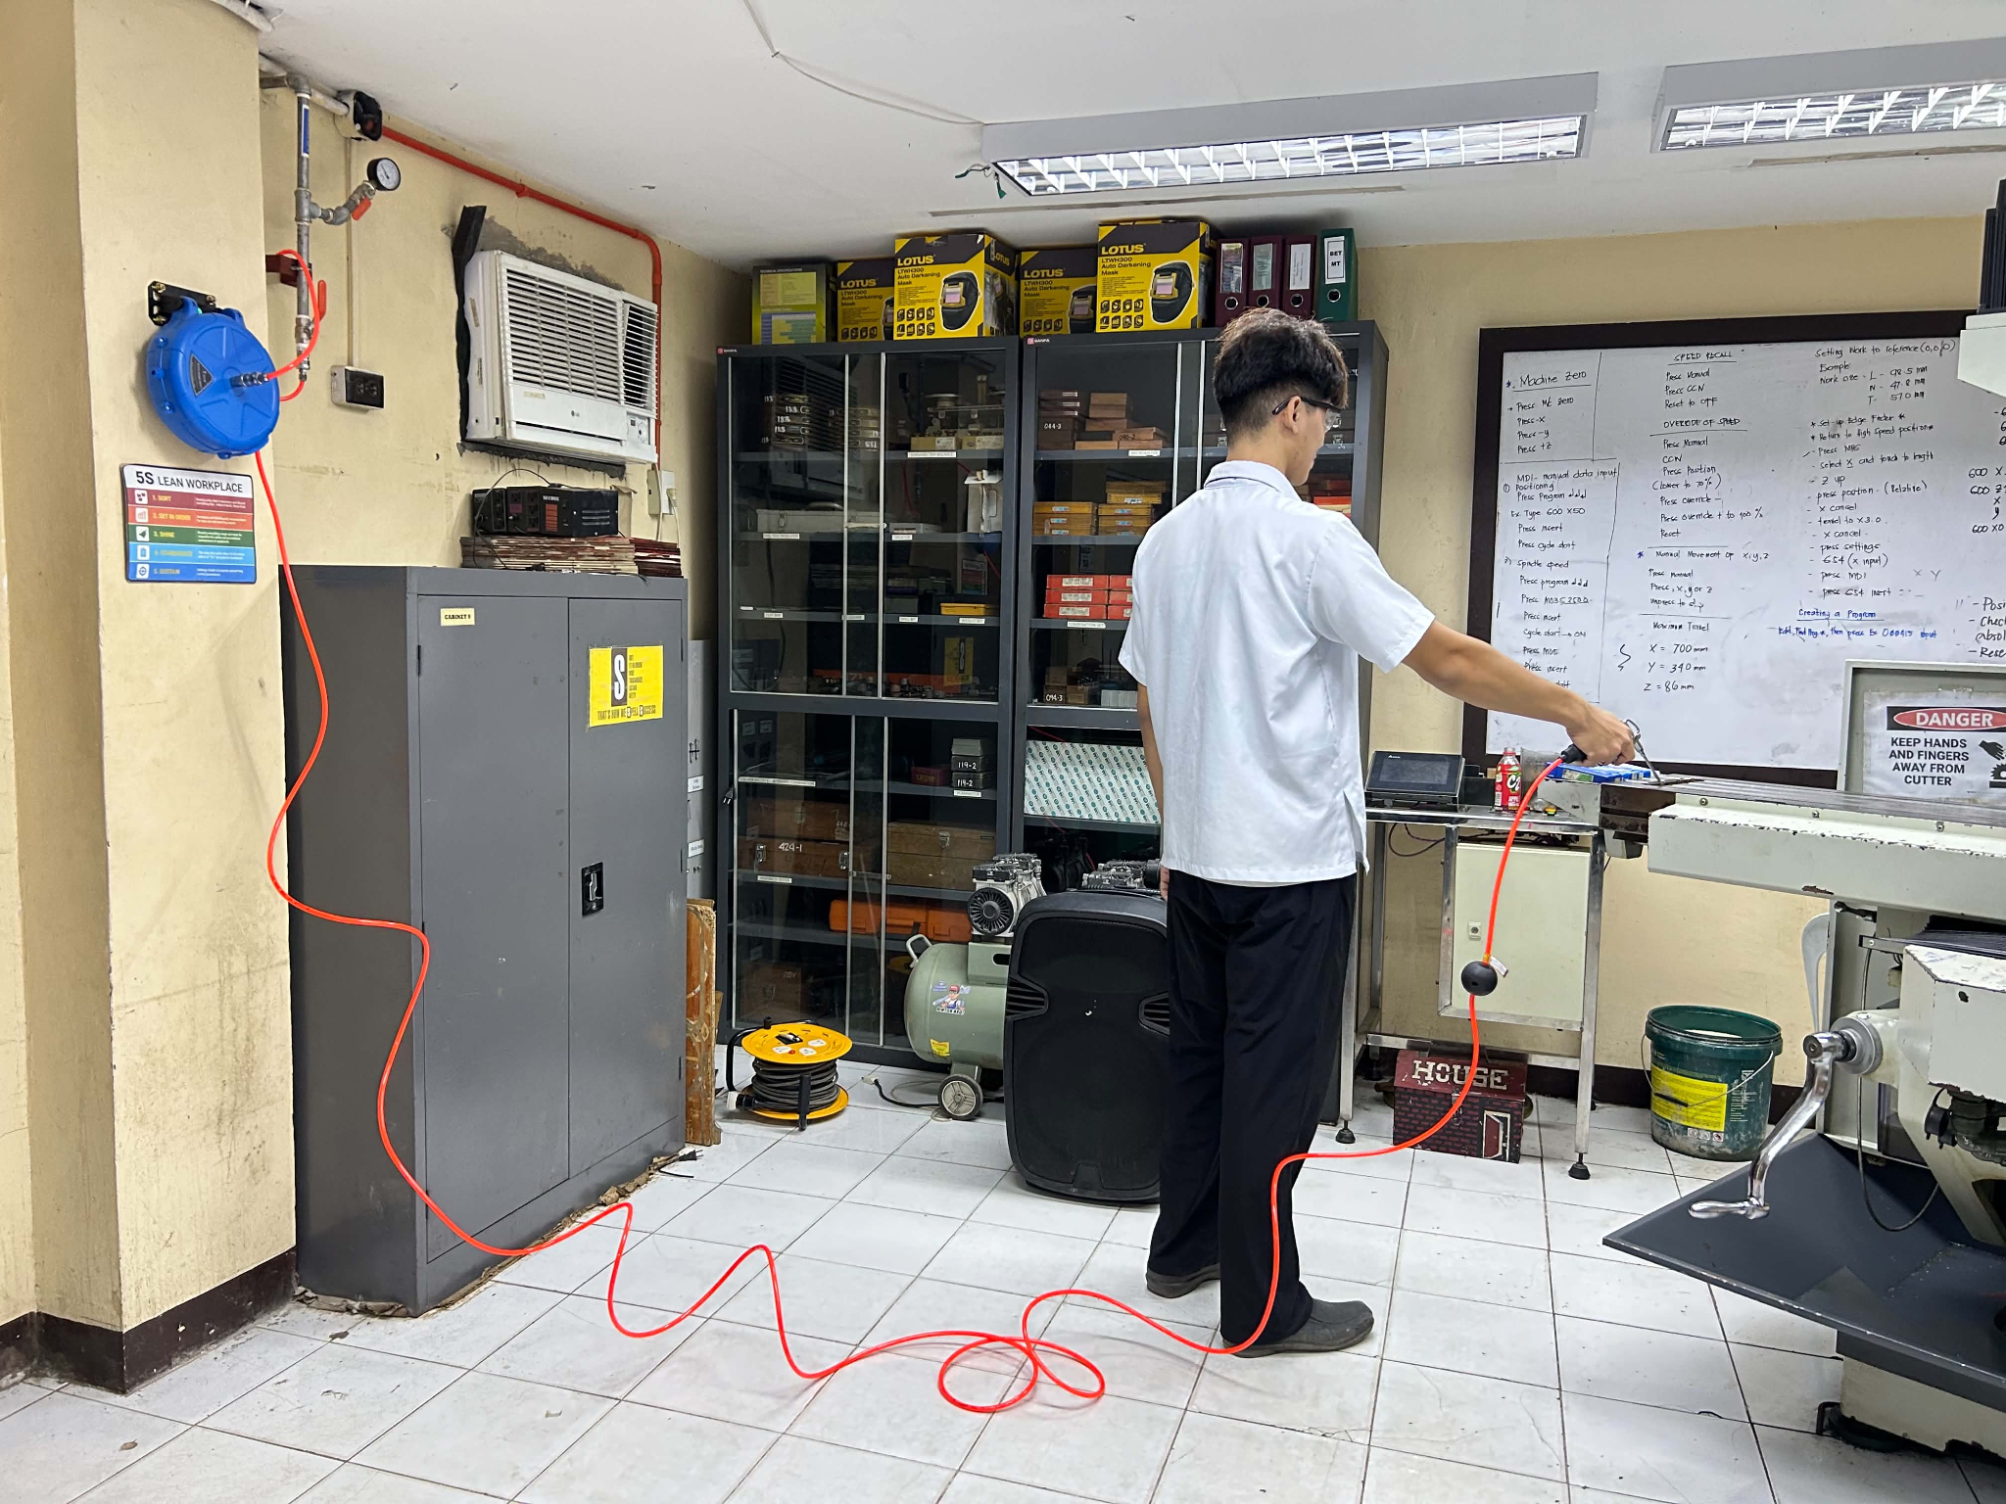
07 FIGURE 02

08 Positioning the Air Blow Gun
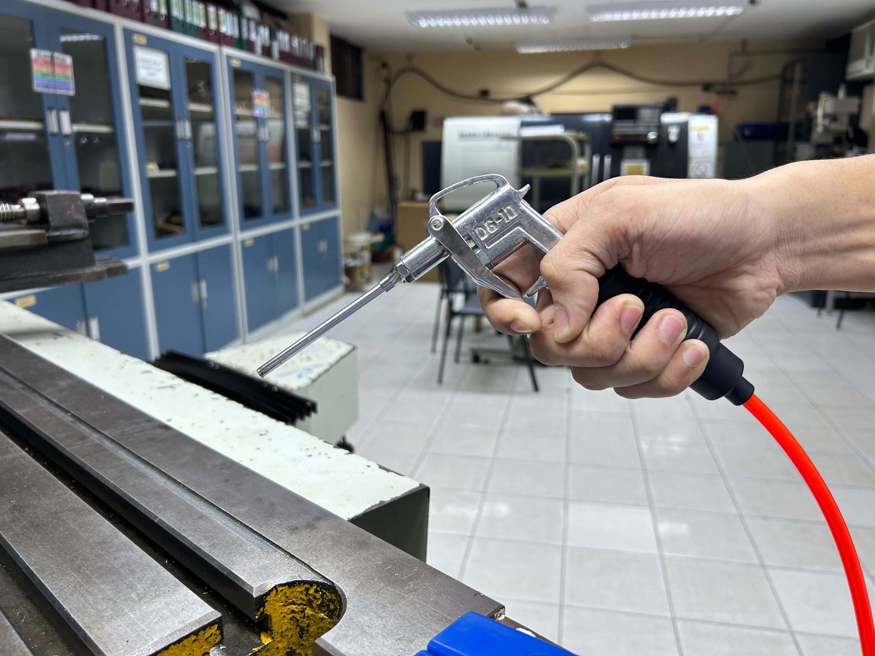
08 FIGURE 01
Hold the air blow gun firmly and position its nozzle approximately 2 inches from the worktable surface. Maintain a stable position and direct the nozzle away from yourself and other people.
Squeeze the air blow gun trigger to release compressed air and clean the worktable or designated work area. Direct the airflow away from yourself and other people.

D. Shutting Down and Storing the Equipment
9 Closing the Upper Ball Valve
9 FIGURE 01
Close the upper ball valve to stop the compressed air supply to the hose reel before disconnecting or storing the equipment.

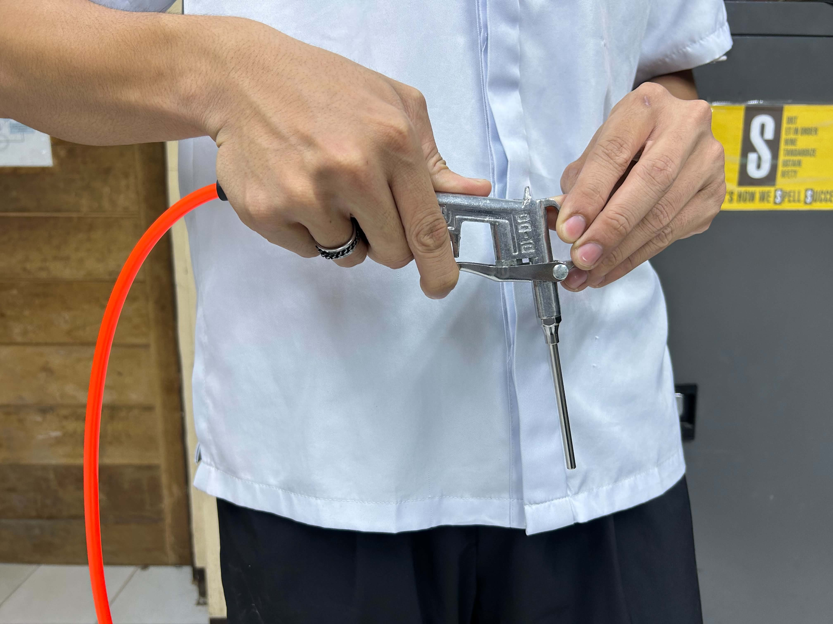
10 Releasing the Remaining Compressed Air
10 FIGURE 01
After closing the valve, squeeze the air blow gun trigger to release the remaining air in the hose. Make sure that the tool is facing downward & the system is depressurized before disconnecting the tool.

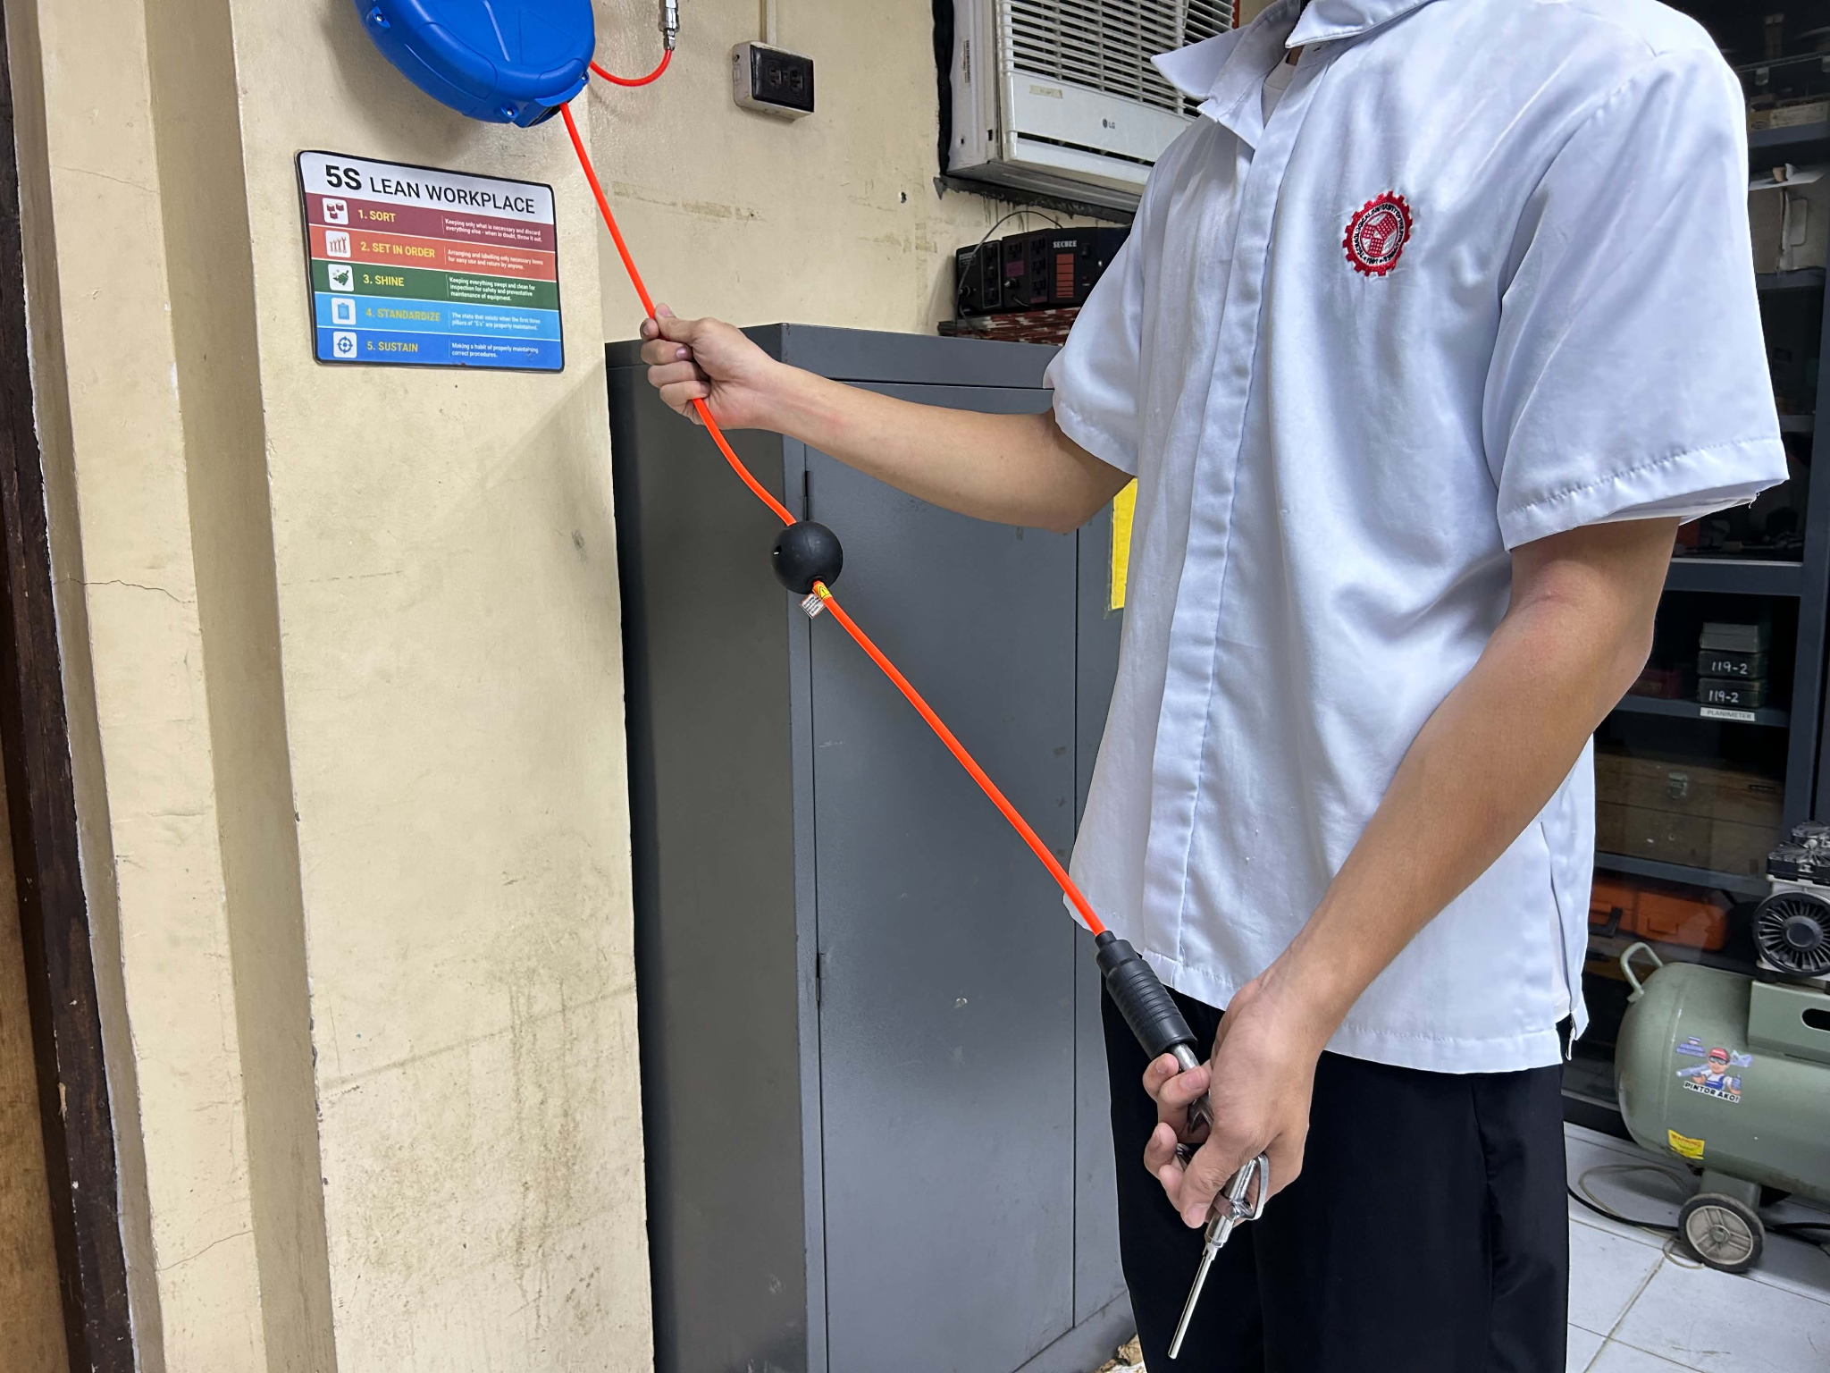
11 Retracting the Hose Safely
11 FIGURE 01
Guide the hose back into the reel slowly and carefully. Do not release it suddenly, as the hose may retract quickly and cause injury or damage.

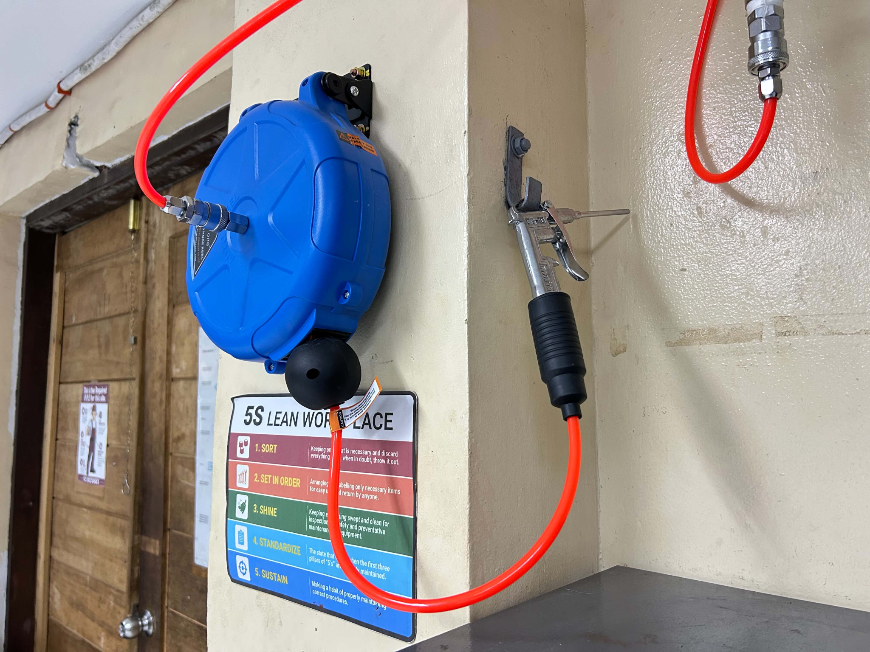
12 Storing the Air Blow Gun and Organizing the Work Area
12 FIGURE 01
Return the air blow gun to its designated holder or storage location, if available, and ensure that the work area is clean and organized.

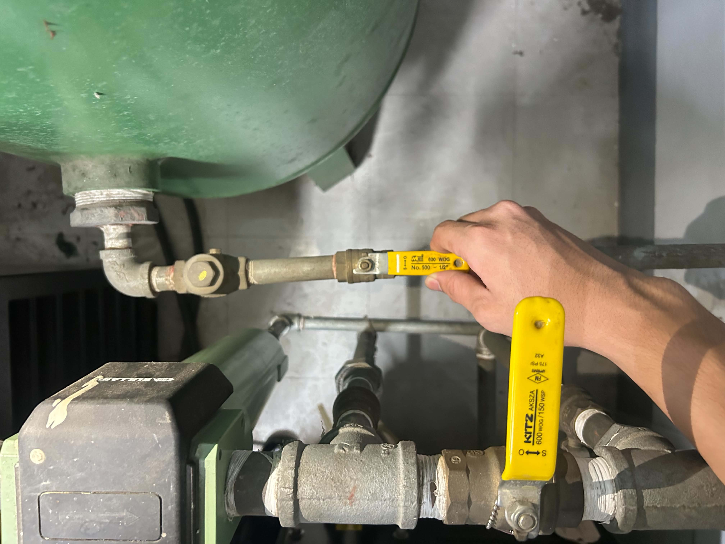
13 Close the Air Receiver Tank Ball Valve
13 FIGURE 01
Locate the ball valve on the air receiver tank and slowly turn it to the closed position. This stops the flow of compressed air from entering the distribution system and helps prevent air from continuing to flow through the connected pipes and outlets.

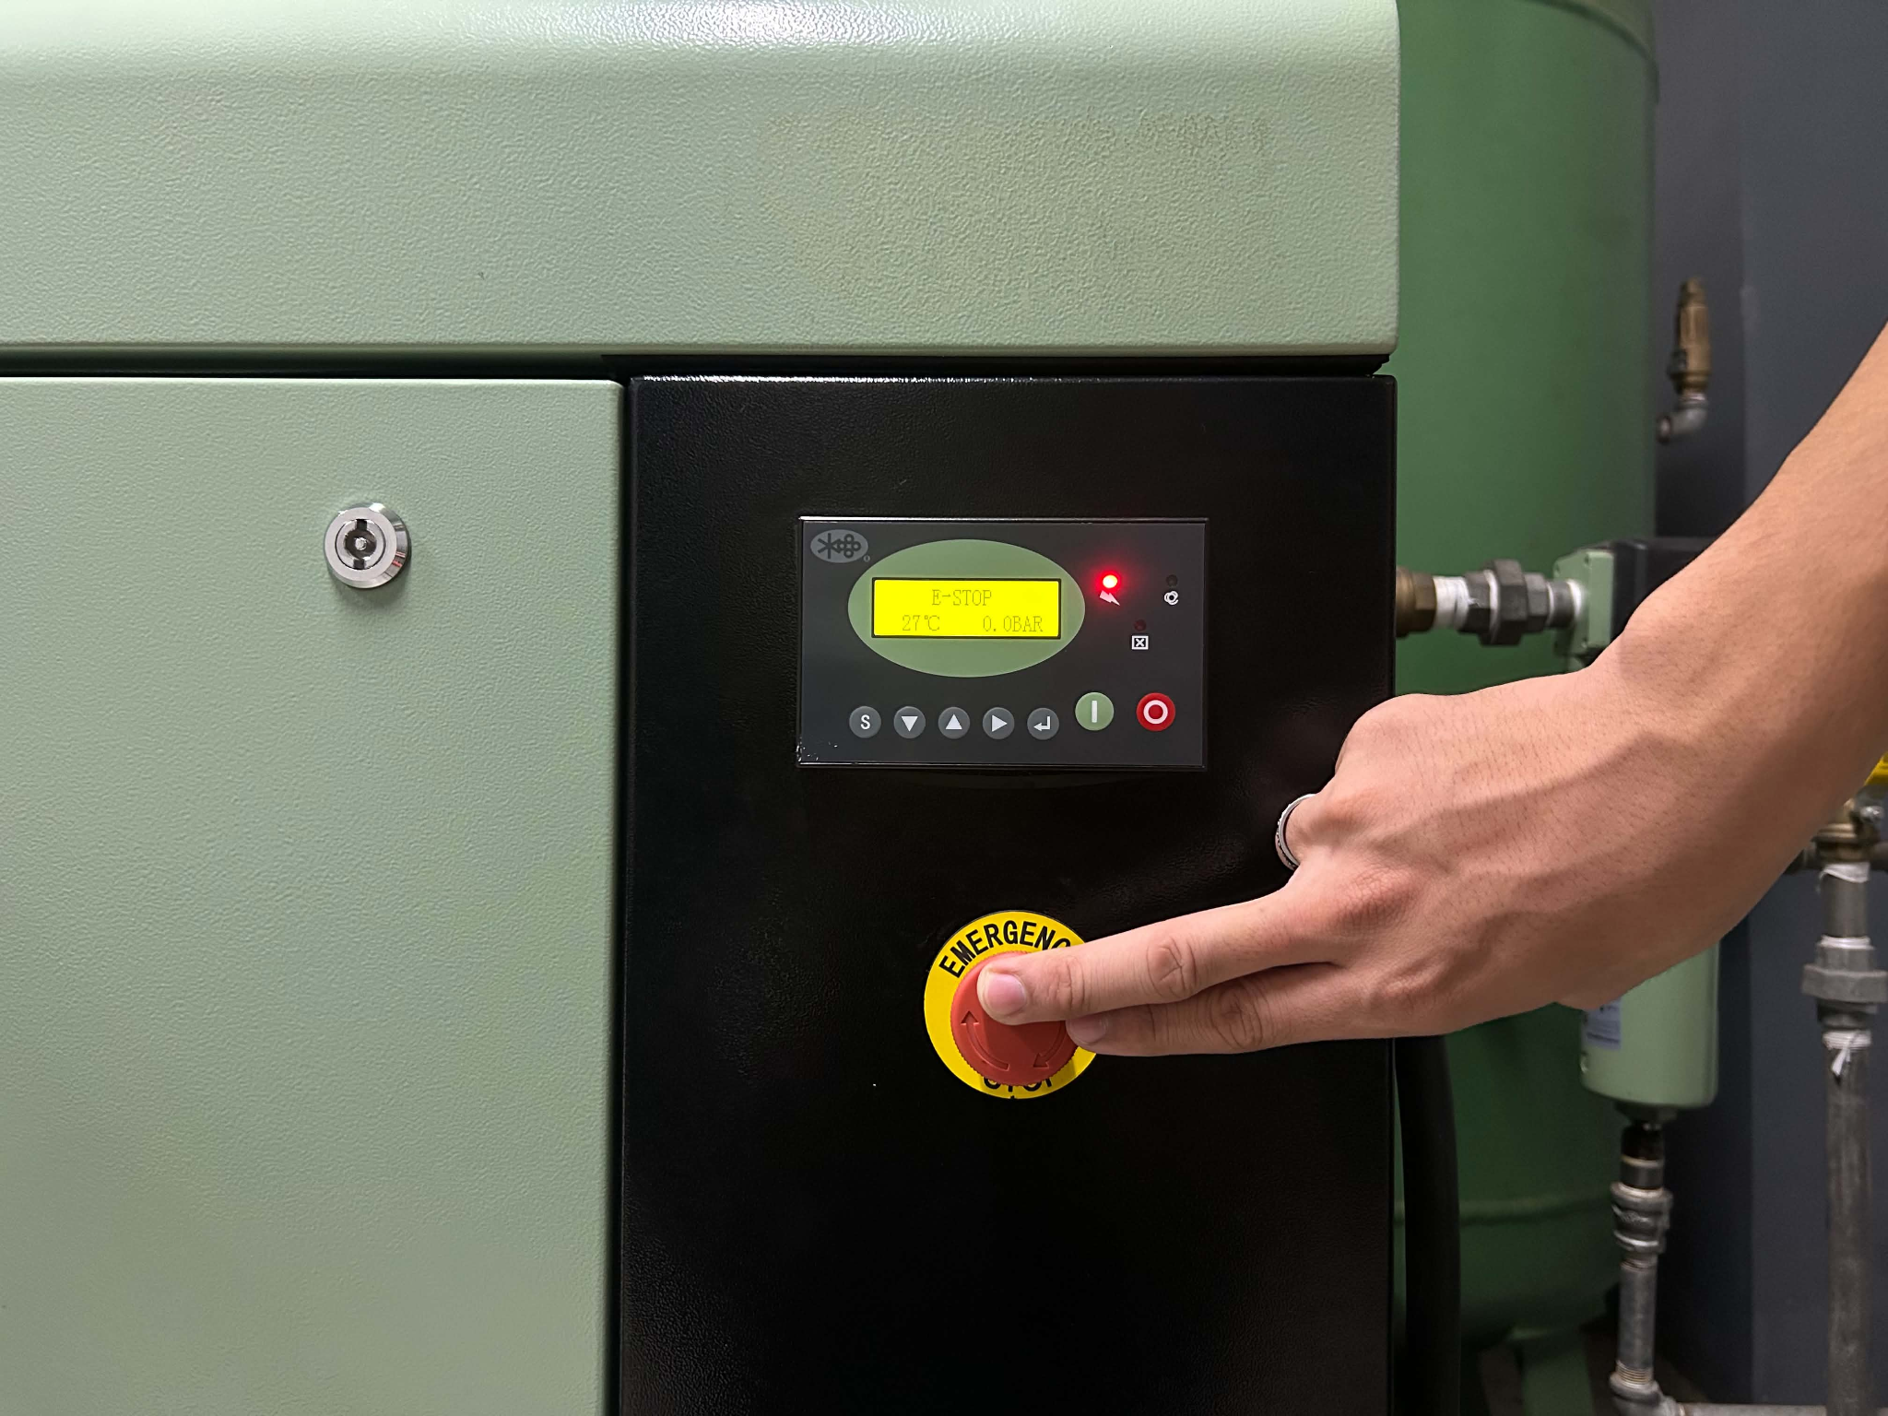
14 Turn Off the Air Compressor.
14 FIGURE 01
Locate the control panel of the air compressor and press the emergency stop button first, followed by the OFF button.
Ensure that the motor is no longer running and that the system shows no signs of continued operation before proceeding to the next step.
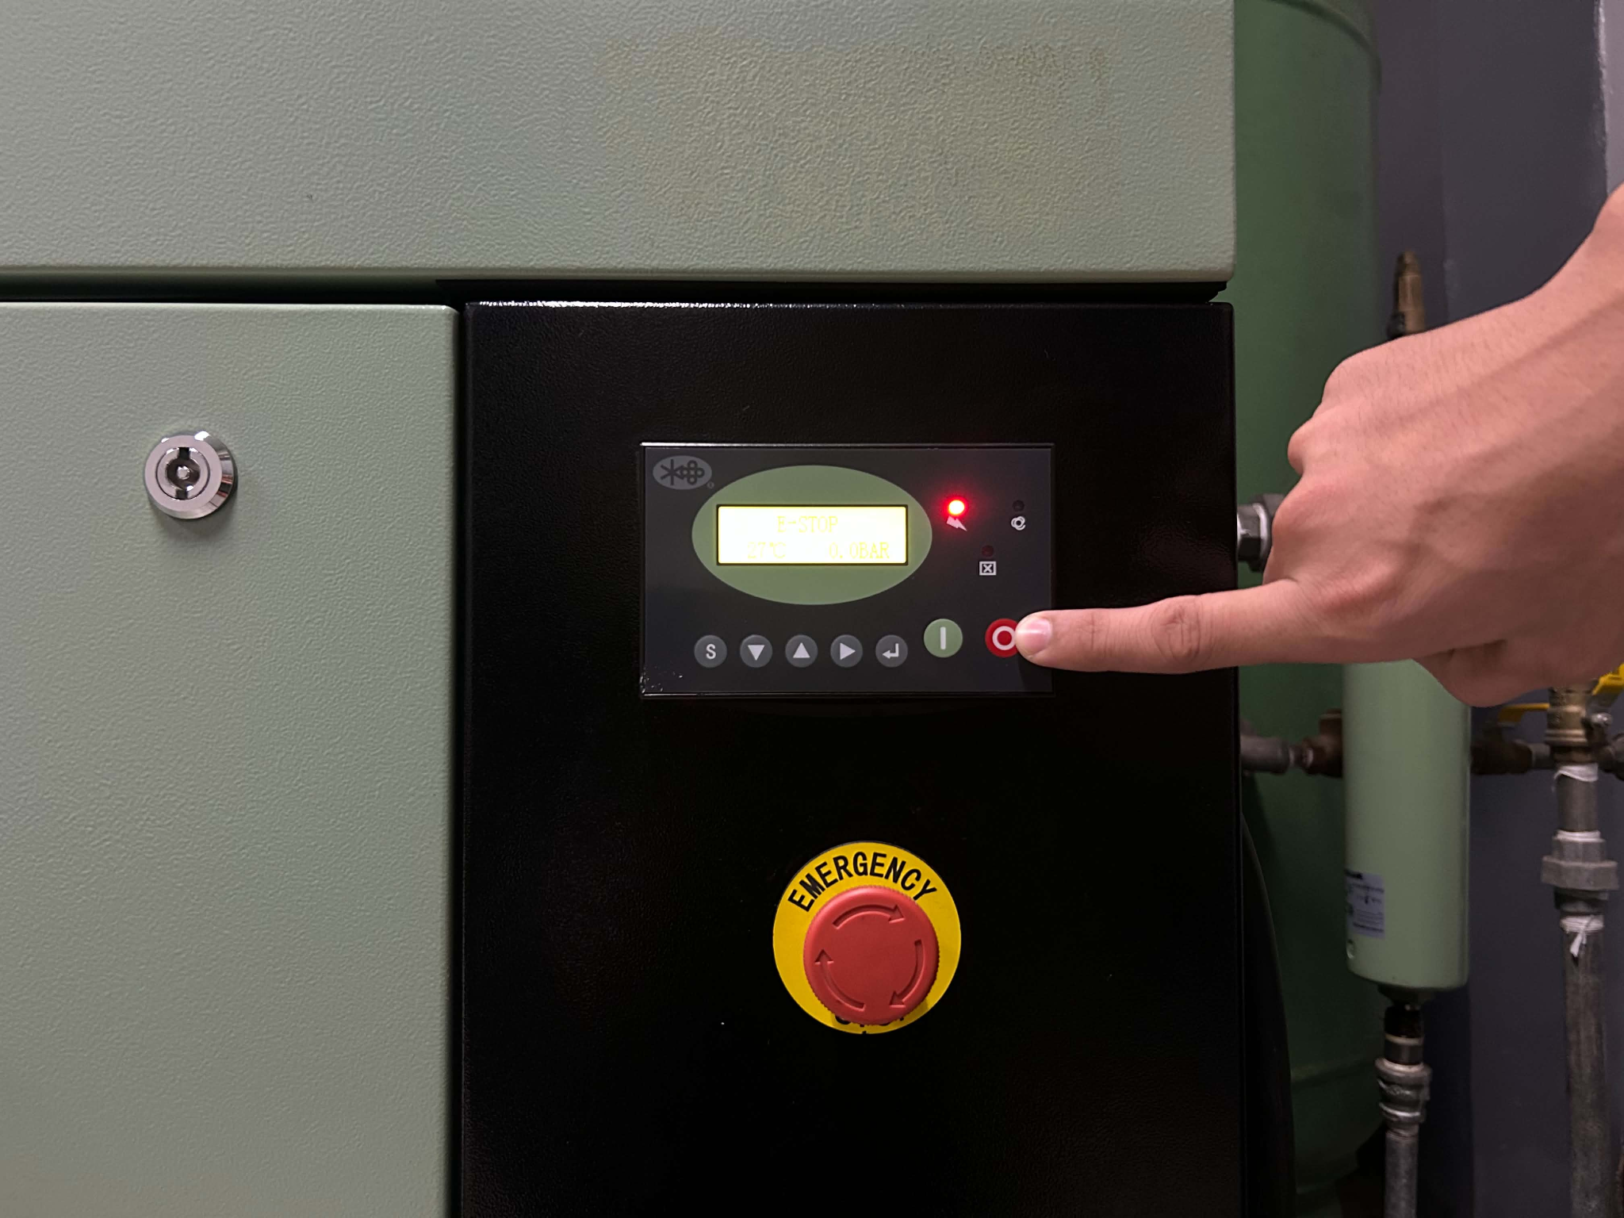
14 FIGURE 02

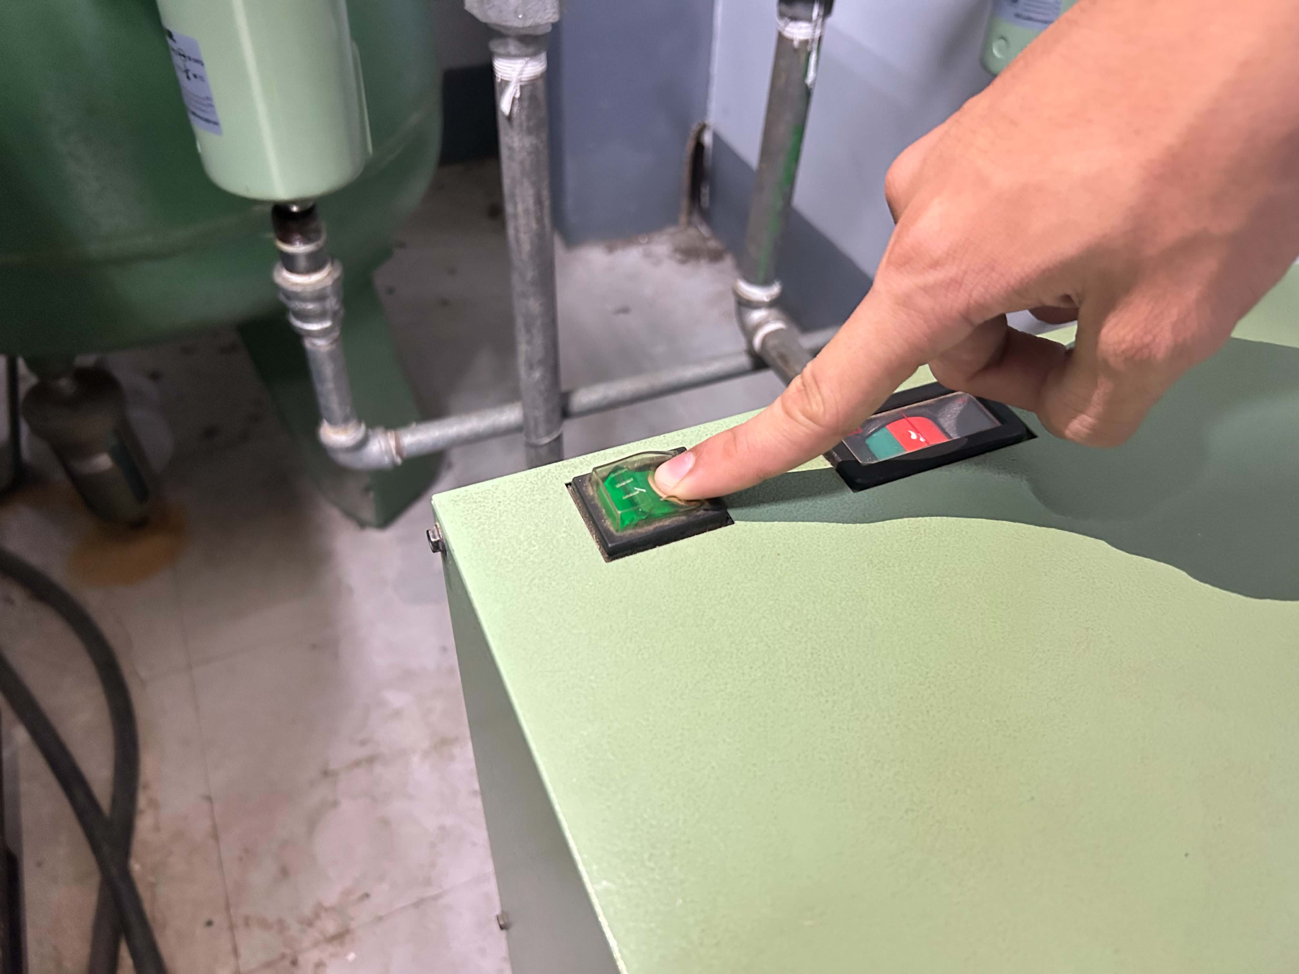
15 Turn Off the Refrigerant Air Dryer.
15 FIGURE 01
Locate the refrigerant air dryer beside the air compressor and switch it off according to the manufacturer's shutdown instructions.

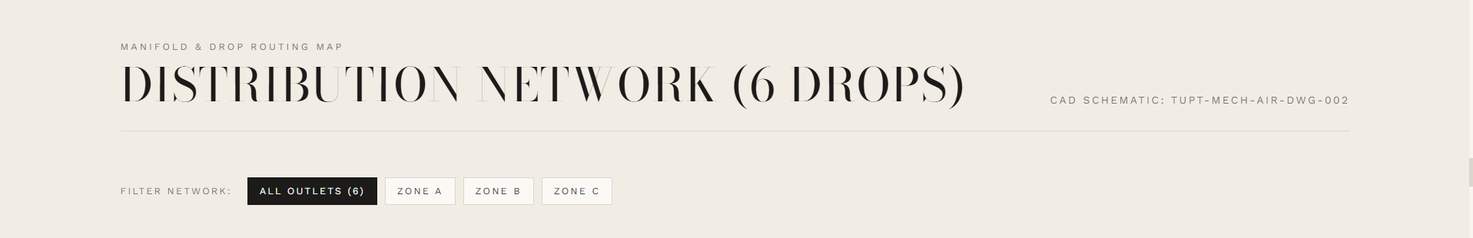
- Manifold & Drop Routing Map REMOVE
- DISTRIBUTION NETWORK (6 DROPS)
Change it to: AIR OUTLETS
- CAD Schematic: TUPT-MECH-AIR-DWG-002 REMOVE
DISTRIBUTION OUTLETS:
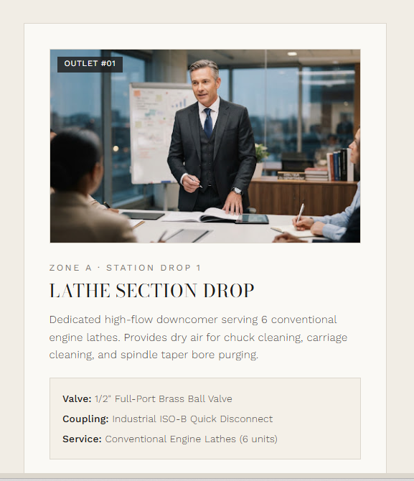
ALL OUTLET (6)
WORKSHOP AREA
CNC AREA
ADVANCE MACHINING AREA

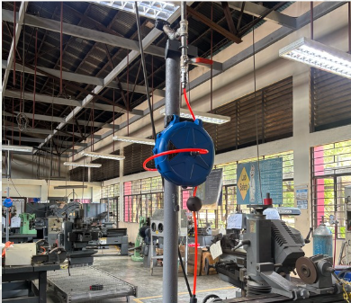
WORKSHOP AREA
1. ZONE A STATION DROP 1 - REMOVE
2. LATHE SECTION DROP
Change to: OUTLET 1
3. Dedicated highflow…
Change to:
4. Yung nasa Box
Change to:
AREA: Workshop Area
REQUIRED PSI: 90-120 PSI
USE: PNEUMATIC TOOLS
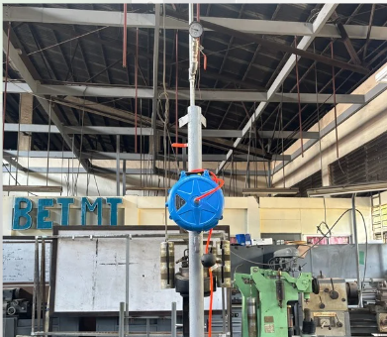
1. ZONE A STATION DROP 1 - REMOVE
2. LATHE SECTION DROP
Change to: OUTLET 2
3. Dedicated highflow…
Change to:
4. Yung nasa Box
Change to:
AREA: Workshop Area
REQUIRED PSI: 30 PSI
USE: Cleaning Operation

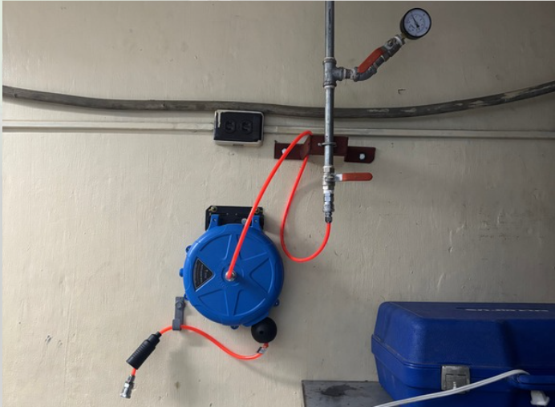
CNC AREA
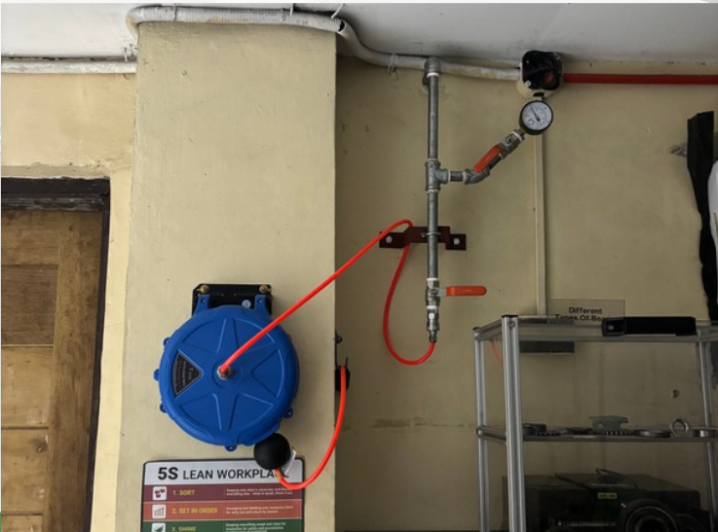
1. ZONE A STATION DROP 1 - REMOVE
2. LATHE SECTION DROP
Change to: OUTLET 3
3. Dedicated highflow…
Change to:
4. Yung nasa Box
Change to:
AREA: CNC Area
REQUIRED PSI: 30 PSI
USE: Cleaning Operation
1. ZONE A STATION DROP 1 - REMOVE
2. LATHE SECTION DROP
Change to: OUTLET 4
3. Dedicated highflow…
Change to:
4. Yung nasa Box
Change to:
AREA: CNC Area
REQUIRED PSI: 30 PSI
USE: Cleaning Operation

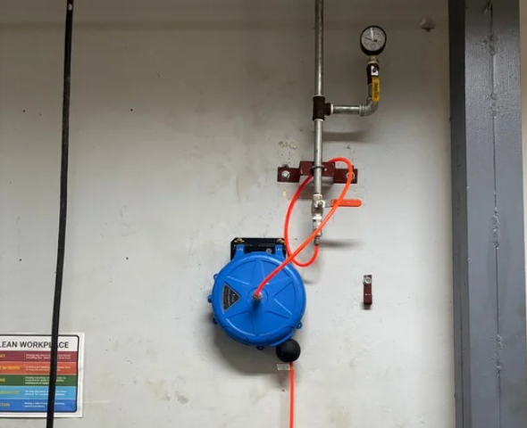
ADVANCE MACHINING AREA
1. ZONE A STATION DROP 1 - REMOVE
2. LATHE SECTION DROP
Change to: OUTLET 5
3. Dedicated highflow…
Change to:
4. Yung nasa Box
Change to:
AREA: Advance Machining Area
REQUIRED PSI: 30 PSI
USE: Cleaning Operation
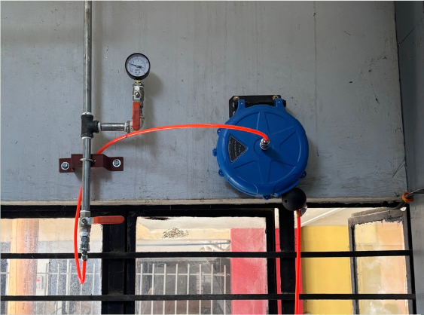
1. ZONE A STATION DROP 1 - REMOVE
2. LATHE SECTION DROP
Change to: OUTLET 6
3. Dedicated highflow…
Change to:
4. Yung nasa Box
Change to:
AREA: Advance Machining Area
REQUIRED PSI: 30 PSI
USE: Cleaning Operation

